UNIT I — INTRODUCTION TO DISTRIBUTED COMPUTING
─────────────────────────────────────────────────────────────────
INTRODUCTION TO DISTRIBUTED COMPUTING
Distributed computing is a computing paradigm in which multiple independent computers, known as nodes, are connected through a network and work together to perform a common task. These systems share resources such as processing power, storage, and data while appearing to users as a single integrated system.
Instead of relying on one central machine, distributed systems divide workload across several machines to improve performance, reliability, and scalability. Each node may perform different functions such as computation, data storage, or coordination.
Distributed computing is widely used in cloud computing, big data processing, artificial intelligence, banking systems, social media platforms, and scientific research.
─────────────────────────────────────────────────────────────────
CHARACTERISTICS OF DISTRIBUTED SYSTEMS
1. Resource Sharing
Distributed systems allow sharing of hardware resources (processors, storage devices), software resources (applications, services), and data across multiple nodes. This improves efficiency and reduces cost.
2. Concurrency
Multiple processes run at the same time on different machines. This enables parallel execution of tasks, improving system throughput and response time.
3. Scalability
The system can grow by adding more machines without affecting existing performance. Scalability can be achieved in terms of:
- Size (adding more nodes)
- Geographic expansion
- Administrative scalability
4. Fault Tolerance
Failure of one or more nodes does not crash the entire system. Redundancy and replication techniques allow continued operation even during hardware or network failures.
5. Transparency
The complexity of the distributed system is hidden from users. Transparency types include:
- Location transparency
- Access transparency
- Failure transparency
- Replication transparency
Users experience the system as a single unified platform.
─────────────────────────────────────────────────────────────────
ISSUES IN DISTRIBUTED SYSTEMS
1. Data Storage and Retrieval Issues
In distributed systems, data is stored across multiple nodes. This causes several challenges:
- Maintaining data consistency among replicas
- Handling network latency during access
- Ensuring data availability during node failures
- Preventing data duplication and conflicts
- Managing synchronization of updates
When multiple users access and modify data simultaneously, conflicts may occur. Special protocols such as replication control and consistency models are required to solve these problems.
─────────────────────────────────────────────────────────────────
2. Communication Overhead
Distributed nodes communicate using network messages instead of direct memory access. This introduces:
- Transmission delays
- Increased bandwidth usage
- Message synchronization complexity
- Network congestion
Frequent communication can slow down system performance. Efficient protocols, message batching, and compression techniques are used to reduce overhead.
─────────────────────────────────────────────────────────────────
3. Synchronization
Multiple nodes may access shared resources simultaneously. Without proper coordination, race conditions and inconsistent data may occur. Synchronization mechanisms such as distributed locks, timestamps, and coordination protocols are required.
─────────────────────────────────────────────────────────────────
4. Fault Handling
Failures are common due to network issues, hardware breakdown, or software crashes. Systems must detect failures and recover automatically using redundancy, replication, and checkpointing.
─────────────────────────────────────────────────────────────────
GOALS OF DISTRIBUTED SYSTEMS
1. Performance Improvement
By executing tasks in parallel across multiple machines, computation time is significantly reduced.
2. Resource Utilization
Idle resources across machines can be efficiently used.
3. Reliability and Availability
Replication ensures services remain available even if some nodes fail.
4. Scalability
System can expand easily without redesign.
5. Flexibility
Supports heterogeneous hardware and software platforms.
─────────────────────────────────────────────────────────────────
AI AND DATA SCIENCE IN DISTRIBUTED COMPUTING
Distributed computing plays a crucial role in handling large-scale AI and data science workloads.
Distributing Computational Tasks
Large datasets and complex AI models require massive computational power. Tasks are divided into smaller subtasks and executed in parallel on multiple machines. This enables:
- Faster data processing
- Efficient model training
- Load balancing
- High scalability
Diagram required here — Task Distribution Architecture

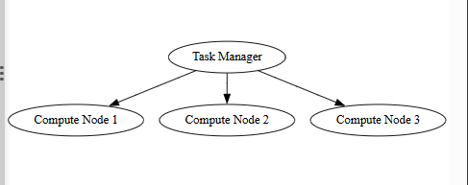─────────────────────────────────────────────────────────────────
Handling Large Volumes of Data
Distributed storage systems split massive datasets across nodes. Parallel data processing frameworks analyze data simultaneously, enabling big data analytics and real-time processing.
─────────────────────────────────────────────────────────────────
USE CASES OF AI AND DATA SCIENCE IN DISTRIBUTED SYSTEMS
1. Predictive Maintenance
Sensors generate continuous machine data across factories. Distributed systems collect and process this data in real time. AI models predict equipment failures before breakdowns occur, reducing downtime and maintenance costs.
─────────────────────────────────────────────────────────────────
2. Healthcare and Medical Diagnostics
Patient records, medical images, and sensor data are stored across hospitals. Distributed AI systems analyze this data to:
- Detect diseases early
- Analyze medical scans
- Monitor patients remotely
- Support clinical decisions
This improves healthcare quality and efficiency.
─────────────────────────────────────────────────────────────────
3. Fraud Detection
Distributed systems analyze millions of transactions in real time to detect suspicious patterns using machine learning algorithms.
─────────────────────────────────────────────────────────────────
4. Intelligent Transportation Systems
Traffic data from sensors, GPS, and cameras is processed across distributed nodes to optimize routes, reduce congestion, and improve safety.
─────────────────────────────────────────────────────────────────
5. Supply Chain Optimization
AI analyzes distributed logistics data to manage inventory, predict demand, and improve delivery efficiency.
─────────────────────────────────────────────────────────────────
6. Energy Management
Smart grids collect energy usage data across cities. Distributed AI optimizes energy distribution and reduces waste.
─────────────────────────────────────────────────────────────────
7. Customer Behavior Analysis
Large-scale customer data is processed to predict preferences, improve marketing strategies, and enhance user experience.
─────────────────────────────────────────────────────────────────
8. Natural Language Processing (NLP)
Distributed computing enables training of large language models on massive text datasets for translation, chatbots, and sentiment analysis.
─────────────────────────────────────────────────────────────────
Characteristics of Distributed Systems
A distributed system is a collection of independent computers connected through a network that coordinate their actions by passing messages to achieve a common goal. Such systems possess several defining characteristics that distinguish them from centralized systems.
─────────────────────────────────────────────────────────────────
1. Resource Sharing
Resource sharing is a fundamental characteristic of distributed systems. Resources such as files, databases, printers, computational power, and services are shared among multiple users and nodes.
Through network communication, users can access remote resources as if they were local. This improves utilization of hardware and software resources and reduces overall cost.
─────────────────────────────────────────────────────────────────
2. Concurrency
Concurrency refers to the simultaneous execution of multiple processes on different machines. Since distributed systems consist of multiple nodes, each node can execute tasks independently.
This parallel execution improves system throughput and reduces response time. However, concurrency requires coordination mechanisms to avoid data inconsistency and race conditions.
─────────────────────────────────────────────────────────────────
3. Scalability
Scalability is the ability of a system to handle increasing workload by adding more resources without significantly affecting performance.
Scalability can be classified into:
- Size scalability – Increasing the number of nodes.
- Geographical scalability – Expanding across different locations.
- Administrative scalability – Supporting multiple organizations or domains.
A well-designed distributed system should maintain performance even as the number of users or nodes increases.
─────────────────────────────────────────────────────────────────
4. Fault Tolerance
In distributed systems, failures are common due to network issues, hardware crashes, or software errors. Fault tolerance ensures that the system continues functioning even when some components fail.
This is achieved through:
- Data replication
- Redundant components
- Failure detection mechanisms
- Recovery protocols
Fault tolerance improves system reliability and availability.
─────────────────────────────────────────────────────────────────
5. Transparency
Transparency hides the complexity of the distributed system from users and applications. The system appears as a single unified entity.
Types of transparency include:
- Access Transparency – Uniform access to local and remote resources.
- Location Transparency – Resource location is hidden.
- Replication Transparency – Multiple copies appear as one.
- Failure Transparency – System masks component failures.
- Concurrency Transparency – Simultaneous sharing without interference.
Transparency simplifies system usage and improves user experience.
─────────────────────────────────────────────────────────────────
6. Heterogeneity
Distributed systems often consist of different hardware platforms, operating systems, and network technologies. They must support interoperability between heterogeneous components.
Middleware and standard communication protocols ensure compatibility.
─────────────────────────────────────────────────────────────────
7. Openness
An open distributed system follows standard protocols and interfaces, allowing components from different vendors to interoperate. This promotes flexibility and extensibility.
─────────────────────────────────────────────────────────────────
8. Security
Since communication occurs over networks, distributed systems must ensure:
- Authentication
- Authorization
- Data encryption
- Protection against cyber attacks
Security mechanisms protect data integrity and confidentiality.
─────────────────────────────────────────────────────────────────
Issues in Distributed Systems
Distributed systems face several technical challenges due to their decentralized nature, network dependency, and concurrent operation of multiple nodes. These issues directly affect system performance, reliability, and data integrity.
─────────────────────────────────────────────────────────────────
1. Data Storage and Retrieval Issues
In distributed systems, data is stored across multiple machines rather than in a single centralized location. While this improves scalability and availability, it introduces multiple complications.
One major issue is data consistency. Since multiple replicas of data exist at different nodes, updating one copy does not immediately update others. This can lead to outdated or conflicting data being accessed by users.
Another challenge is synchronization of updates. When multiple users modify the same data simultaneously, conflicts may occur, requiring complex coordination protocols to maintain correctness.
Network latency also affects retrieval speed. Accessing remote data depends on network performance, which may cause delays or timeouts.
Fault tolerance and data loss risks are also significant. Node failures can make some data temporarily unavailable unless replication mechanisms are in place.
Load imbalance may occur when some storage nodes are heavily accessed while others remain underutilized.
Thus, efficient data partitioning, replication strategies, and consistency models are required to manage distributed data effectively.
─────────────────────────────────────────────────────────────────
2. Communication Overhead
Nodes in a distributed system communicate through message passing over networks. Unlike centralized systems, data and control signals must be transmitted across physical links.
This results in:
- Increased transmission delays
- High bandwidth consumption
- Network congestion
- Message synchronization complexity
Frequent inter-node communication reduces overall system performance. Optimized communication protocols and minimizing unnecessary message exchange are essential.
─────────────────────────────────────────────────────────────────
3. Coordination and Synchronization
Multiple nodes operate concurrently and may share resources or data. Without proper coordination, issues such as race conditions, deadlocks, and inconsistent states may occur.
Distributed synchronization mechanisms such as logical clocks, distributed locks, and coordination services are used to maintain correct operation.
─────────────────────────────────────────────────────────────────
4. Reliability and Fault Management
Failures are inevitable in distributed environments due to hardware crashes, software bugs, or network breakdowns.
Challenges include:
- Detecting failed nodes
- Recovering lost data
- Maintaining service availability
- Handling partial system failures
Replication, checkpointing, and automatic recovery mechanisms are used to improve reliability.
─────────────────────────────────────────────────────────────────
5. Scalability and Performance Bottlenecks
As the system grows, managing resources efficiently becomes difficult. Bottlenecks may occur in:
- Network traffic
- Central coordinators
- Data storage servers
Proper load balancing and decentralized architectures are required to maintain performance.
─────────────────────────────────────────────────────────────────
Distributed systems must carefully address these issues to ensure efficient, reliable, and scalable operation in real-world environments.
─────────────────────────────────────────────────────────────────
Communication Overhead in Distributed Computing
Communication overhead refers to the additional time, resources, and processing cost involved in exchanging data and control messages among multiple nodes in a distributed system. Since nodes are connected through a network rather than shared memory, all coordination and data transfer must occur through message passing.
This overhead is one of the major factors affecting the performance and efficiency of distributed systems.
─────────────────────────────────────────────────────────────────
Causes of Communication Overhead
1. Network Latency
Every message sent between nodes experiences delay due to transmission time, routing, and processing at intermediate devices. High latency slows down task execution and synchronization.
─────────────────────────────────────────────────────────────────
2. Bandwidth Limitations
Large volumes of data exchanged between nodes consume network bandwidth. When bandwidth is insufficient, congestion occurs, increasing delays and packet loss.
─────────────────────────────────────────────────────────────────
3. Frequent Message Exchange
Distributed algorithms often require continuous coordination, acknowledgements, and status updates. Excessive messaging increases processing load and slows system performance.
─────────────────────────────────────────────────────────────────
4. Serialization and Deserialization Costs
Data must be converted into transmittable formats before sending and reconstructed upon receiving. This consumes CPU time and adds delay.
─────────────────────────────────────────────────────────────────
5. Synchronization Delays
Nodes may need to wait for responses from others before proceeding, leading to idle time and reduced parallel efficiency.
─────────────────────────────────────────────────────────────────
Effects of Communication Overhead
- Increased execution time of distributed applications
- Reduced system throughput
- Network congestion and performance degradation
- Higher energy and resource consumption
─────────────────────────────────────────────────────────────────
Techniques to Reduce Communication Overhead
- Message batching and aggregation
- Data compression
- Caching frequently accessed data locally
- Optimized communication protocols
- Reducing synchronization frequency
─────────────────────────────────────────────────────────────────
Communication overhead is a critical limitation in distributed computing. Efficient system design aims to minimize unnecessary data transfer while maintaining coordination and consistency among distributed nodes.
─────────────────────────────────────────────────────────────────
Goals of Distributed Systems
The primary objective of distributed systems is to enable multiple independent computers to work together efficiently as a unified system. The design of distributed systems focuses on improving performance, reliability, scalability, and resource utilization while maintaining transparency and flexibility.
─────────────────────────────────────────────────────────────────
1. Resource Sharing
One of the fundamental goals of distributed systems is to allow users and applications to share resources such as hardware, software, data, and services across multiple nodes.
This ensures efficient utilization of available resources and reduces redundancy. For example, multiple users can access a shared database or computing cluster from different locations.
─────────────────────────────────────────────────────────────────
2. Performance Improvement
Distributed systems aim to improve overall system performance by dividing tasks among multiple machines. Parallel processing enables faster execution of large-scale computations.
By distributing workload, the system reduces processing time and improves response speed.
─────────────────────────────────────────────────────────────────
3. Scalability
Scalability refers to the system’s ability to grow and handle increasing workload without significant degradation in performance.
A distributed system should support:
- Addition of new nodes
- Increased number of users
- Expansion across geographic regions
Scalability ensures long-term adaptability.
─────────────────────────────────────────────────────────────────
4. Reliability and Fault Tolerance
Failures are common in large-scale systems. A major goal of distributed systems is to continue operating even when some components fail.
This is achieved through redundancy, replication, and automatic recovery mechanisms. High reliability increases user trust and service availability.
─────────────────────────────────────────────────────────────────
5. Transparency
Transparency ensures that users perceive the distributed system as a single coherent entity. The complexity of multiple machines, data replication, and network communication is hidden from users.
This simplifies usage and system management.
─────────────────────────────────────────────────────────────────
6. Flexibility and Heterogeneity Support
Distributed systems should support different hardware platforms, operating systems, and network technologies. This flexibility allows integration of diverse components within the same system.
─────────────────────────────────────────────────────────────────
7. Cost Efficiency
By using commodity hardware and distributed resources, organizations can achieve high performance at lower cost compared to centralized supercomputers.
─────────────────────────────────────────────────────────────────
The goals of distributed systems collectively ensure efficient resource utilization, improved performance, reliability, scalability, and seamless user experience in modern computing environments.
─────────────────────────────────────────────────────────────────
Types of Distributed Systems
Distributed systems can be classified into different types based on their architecture, functionality, and method of resource sharing. Each type is designed to address specific application requirements such as performance, scalability, and reliability.
─────────────────────────────────────────────────────────────────
1. Client–Server Distributed Systems
In this model, the system is divided into clients and servers.
Clients request services or resources, while servers process requests and provide responses.
Servers usually manage data storage, computation, and security, while clients handle user interaction.
Examples include web applications, email systems, and database servers.
─────────────────────────────────────────────────────────────────
Diagram required here — Client–Server Architecture
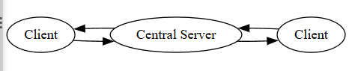─────────────────────────────────────────────────────────────────
2. Peer-to-Peer (P2P) Distributed Systems
In peer-to-peer systems, all nodes have equal roles and can act as both clients and servers. There is no central controlling node.
Each peer can share resources directly with other peers, improving scalability and fault tolerance.
Examples include file-sharing networks and blockchain systems.
─────────────────────────────────────────────────────────────────
Diagram required here — Peer-to-Peer Network
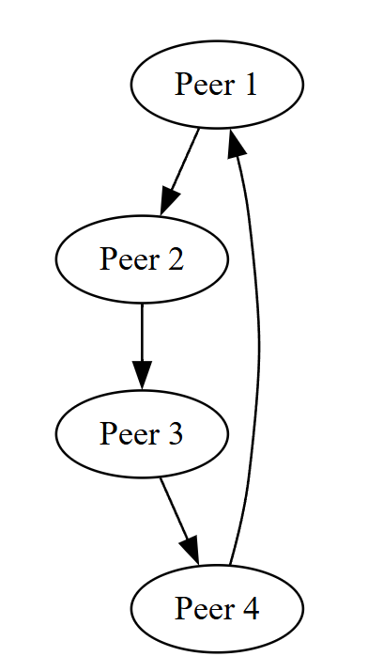─────────────────────────────────────────────────────────────────
3. Cluster Computing Systems
Cluster systems consist of multiple computers connected in a local network working together as a single powerful system.
All nodes perform similar tasks and are managed by a centralized scheduler.
Clusters are commonly used in scientific computing, data analytics, and AI model training.
─────────────────────────────────────────────────────────────────
Diagram required here — Cluster Architecture
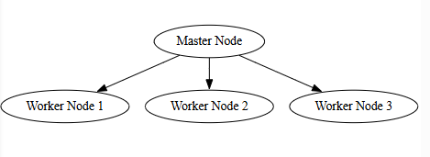─────────────────────────────────────────────────────────────────
4. Distributed Information Systems
These systems manage and share large volumes of structured data across multiple locations.
They include:
- Distributed databases
- Enterprise resource planning systems
- Online transaction systems
They focus on consistency, reliability, and data accessibility.
─────────────────────────────────────────────────────────────────
5. Distributed Real-Time Systems
These systems must respond within strict time limits. Delays may lead to system failure.
Used in:
- Industrial automation
- Air traffic control
- Medical monitoring systems
Real-time constraints are critical in system design.
─────────────────────────────────────────────────────────────────
6. Cloud-Based Distributed Systems
Cloud systems distribute computing resources across massive data centers to deliver services over the internet.
Features include:
- On-demand resource provisioning
- Elastic scalability
- Pay-as-you-use model
Used in web hosting, AI services, and big data platforms.
─────────────────────────────────────────────────────────────────
Distributed systems are classified into these types to meet different application needs such as scalability, reliability, speed, and resource sharing.
─────────────────────────────────────────────────────────────────
Distributed System Models
Distributed system models provide a structured way to understand, design, and analyze how distributed systems are organized and how their components interact. These models describe system structure, communication patterns, and possible behaviors under normal and failure conditions.
Distributed system models are generally classified into:
- 1. Physical Model
- 2. Architectural Model
- 3. Fundamental Model
─────────────────────────────────────────────────────────────────
1. Physical Model
The physical model describes the actual hardware layout of a distributed system. It shows how computers, servers, networks, and devices are physically connected.
In this model, components are geographically distributed and communicate through network links such as LAN, WAN, or the Internet.
Key Features:
- Multiple independent machines
- Connected through communication networks
- No shared memory
- Message-based communication
This model focuses on the real-world deployment of nodes.
─────────────────────────────────────────────────────────────────
Diagram required here — Physical Distribution of Nodes
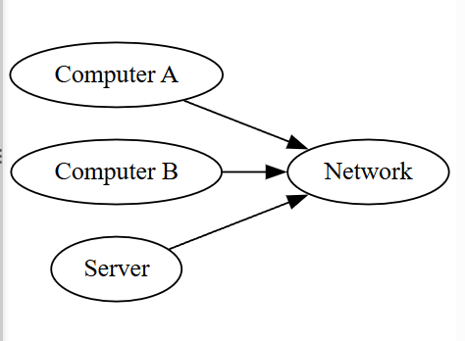─────────────────────────────────────────────────────────────────
2. Architectural Model
The architectural model defines how software components are organized and how they interact with each other.
It focuses on roles of components such as clients, servers, peers, and middleware.
Common architectural styles include:
a) Client–Server Architecture
Clients request services and servers provide services. Servers manage data and computation.
b) Peer-to-Peer Architecture
All nodes act equally and share resources directly.
c) Multi-tier Architecture
System is divided into layers such as presentation layer, application layer, and data layer.
─────────────────────────────────────────────────────────────────
Diagram required here — Multi-tier Distributed Architecture
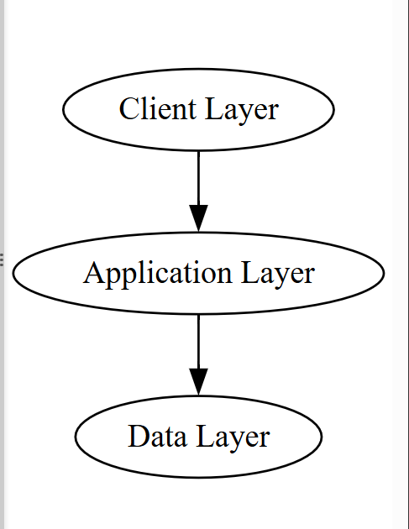─────────────────────────────────────────────────────────────────
3. Fundamental Model
The fundamental model describes system behavior in terms of:
- Communication
- Failure handling
- Security
It helps in understanding how distributed systems operate under real conditions.
a) Interaction Model
Defines how processes communicate and coordinate using message passing and synchronization.
b) Failure Model
Describes types of failures such as:
- Node crashes
- Network failures
- Message loss
- Timing failures
c) Security Model
Addresses threats such as:
- Unauthorized access
- Data tampering
- Eavesdropping
- Denial of service attacks
Security mechanisms like encryption, authentication, and access control are applied.
─────────────────────────────────────────────────────────────────
Importance of Distributed System Models
Distributed system models help in:
- System design and planning
- Performance analysis
- Fault tolerance strategy development
- Security implementation
- Understanding system behavior
They provide a clear framework for building reliable and scalable distributed applications.
─────────────────────────────────────────────────────────────────
AI & Data Science in Distributed Computing
Artificial Intelligence (AI) and Data Science require massive computational power and large-scale data processing. Distributed computing provides the infrastructure needed to process huge datasets efficiently by dividing tasks across multiple machines working in parallel.
The integration of AI and data science with distributed systems enables high-performance analytics, real-time processing, scalability, and reliability.
─────────────────────────────────────────────────────────────────
Role of Distributed Computing in AI & Data Science
AI models and data analytics workloads involve:
- Large datasets (big data)
- Complex computations
- Continuous data streams
- High memory and processing requirements
Single machines cannot handle such workloads efficiently. Distributed systems solve this by:
- Splitting data across nodes
- Running algorithms in parallel
- Sharing computational load
- Ensuring fault tolerance
─────────────────────────────────────────────────────────────────
Distributing Computational Tasks
Large AI and data processing jobs are divided into smaller subtasks and assigned to multiple nodes simultaneously.
This approach is known as parallel processing.
Each node processes a portion of the data or model, and the results are combined to produce the final output.
Benefits:
- Faster execution
- Efficient resource utilization
- Scalability for large workloads
- Reduced processing bottlenecks
This method is widely used in machine learning training, data mining, and real-time analytics.
─────────────────────────────────────────────────────────────────
Handling Large Volumes of Data
Distributed storage systems divide massive datasets across many machines.
Key techniques include:
- Data partitioning (splitting data into chunks)
- Data replication (creating copies for reliability)
- Distributed file systems
Parallel data processing frameworks then analyze different data parts simultaneously.
This enables:
- Big data analytics
- Real-time processing
- High-speed querying
- Scalable storage
─────────────────────────────────────────────────────────────────
Key Challenges in AI-Based Distributed Systems
1. Data Consistency
Ensuring that all nodes maintain correct and updated data copies.
2. Communication Overhead
Large data transfers between nodes increase network load.
3. Synchronization
Coordinating parallel tasks and model updates.
4. Fault Tolerance
Handling node failures without losing data or computation.
5. Load Balancing
Distributing tasks evenly across nodes to avoid performance bottlenecks.
─────────────────────────────────────────────────────────────────
Advantages of Integrating AI & Distributed Computing
- High-speed data processing
- Scalability for growing workloads
- Reliable and fault-tolerant operations
- Cost-efficient resource usage
- Real-time intelligent decision-making
─────────────────────────────────────────────────────────────────
Applications Enabled by AI & Distributed Systems
- Big data analytics platforms
- Cloud-based AI services
- Real-time recommendation systems
- Smart cities and IoT analytics
- Financial fraud detection
- Healthcare diagnostics
- Autonomous systems
─────────────────────────────────────────────────────────────────
The combination of AI, data science, and distributed computing forms the backbone of modern intelligent systems by enabling large-scale, fast, reliable, and scalable data-driven solutions.
─────────────────────────────────────────────────────────────────
Distributing Computational Tasks in Distributed Computing
Distributing computational tasks refers to the process of dividing a large and complex computation into smaller independent subtasks and executing them simultaneously across multiple nodes in a distributed system. Each node performs a portion of the workload, and the partial results are combined to produce the final output.
This approach is essential in handling large-scale data processing and computationally intensive applications such as artificial intelligence, machine learning, scientific simulations, and big data analytics.
─────────────────────────────────────────────────────────────────
Concept and Working Mechanism
In a distributed environment, a central coordinator or task manager breaks a main job into several smaller tasks. These tasks are assigned to different worker nodes based on their processing capacity and availability.
Each worker node processes its assigned task in parallel with others. After completion, the results are sent back to the coordinator, which merges them to generate the final result.
This method significantly reduces execution time and improves system efficiency.
─────────────────────────────────────────────────────────────────
Diagram required here — Distributed Task Execution Model
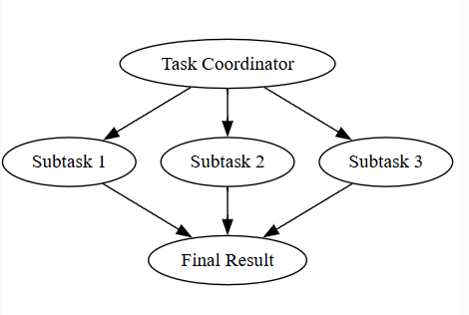─────────────────────────────────────────────────────────────────
Key Techniques Used in Task Distribution
1. Task Partitioning
Large problems are divided into smaller independent tasks that can be processed in parallel.
2. Load Balancing
Tasks are evenly distributed among nodes to avoid overloading any single machine.
3. Parallel Execution
Multiple nodes perform computation simultaneously, reducing overall processing time.
4. Result Aggregation
Partial outputs from all nodes are combined to form the final solution.
─────────────────────────────────────────────────────────────────
Advantages of Distributing Computational Tasks
- Faster processing through parallelism
- Efficient utilization of system resources
- Scalability for large workloads
- Improved system performance
- Capability to process massive datasets
─────────────────────────────────────────────────────────────────
Challenges Involved
- Coordination complexity among nodes
- Communication overhead during result exchange
- Synchronization delays
- Fault handling if nodes fail during execution
─────────────────────────────────────────────────────────────────
Distributing computational tasks is a fundamental technique in distributed computing that enables high-performance processing and forms the backbone of modern AI systems, cloud platforms, and big data frameworks.
─────────────────────────────────────────────────────────────────
Handling Large Volumes of Data and Parallel Processing in Distributed Computing
Handling large volumes of data refers to the ability of distributed systems to store, manage, and process massive datasets that cannot be efficiently handled by a single machine. Parallel processing is the technique used to perform computations on different parts of the data simultaneously across multiple nodes.
Together, these two concepts enable high-speed data analytics, large-scale artificial intelligence training, and real-time processing in modern computing environments.
─────────────────────────────────────────────────────────────────
Distributed Data Storage
In distributed systems, data is divided into smaller blocks and stored across multiple machines instead of one centralized server. This is known as data partitioning.
To ensure reliability and availability, multiple copies of data blocks are stored on different nodes using data replication.
This approach provides:
- High storage scalability
- Fault tolerance
- Faster data access
- Load distribution
Distributed file systems manage these operations automatically.
─────────────────────────────────────────────────────────────────
Parallel Data Processing Mechanism
Parallel processing involves executing multiple computations at the same time on different data segments.
Each node processes a subset of the total data, and results are combined to produce the final output.
This mechanism includes:
- Splitting large datasets into chunks
- Assigning chunks to worker nodes
- Processing simultaneously
- Aggregating results
─────────────────────────────────────────────────────────────────
Diagram required here — Parallel Data Processing Flow
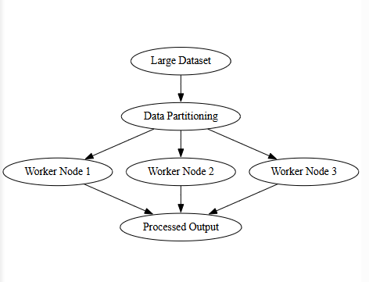─────────────────────────────────────────────────────────────────
Benefits of Handling Big Data with Parallel Processing
- High-speed computation
- Scalability to petabyte-scale data
- Efficient resource utilization
- Support for real-time analytics
- Faster AI model training
─────────────────────────────────────────────────────────────────
Challenges
- Data consistency across nodes
- Communication overhead
- Load balancing issues
- Fault recovery
- Synchronization delays
─────────────────────────────────────────────────────────────────
Distributed handling of large volumes of data combined with parallel processing is essential for modern applications such as big data analytics, cloud computing, artificial intelligence, and real-time processing systems.
─────────────────────────────────────────────────────────────────
Data Storage and Retrieval Issues in Distributed Systems
In distributed systems, data is stored across multiple interconnected nodes rather than in a single centralized location. While this improves scalability and availability, it introduces several technical challenges related to storage management, consistency, and retrieval performance.
Efficient handling of these issues is critical for ensuring reliability, correctness, and system performance.
─────────────────────────────────────────────────────────────────
1. Data Partitioning Challenges
Large datasets are divided into smaller segments and stored across different machines. This is known as data partitioning or sharding.
Improper partitioning may lead to:
- Uneven load distribution
- Frequent cross-node communication
- Performance bottlenecks
Efficient partitioning strategies are required to balance storage and computation across nodes.
─────────────────────────────────────────────────────────────────
2. Data Replication and Consistency
To improve reliability and fault tolerance, multiple copies of data are stored on different nodes. This is called replication.
However, replication introduces consistency challenges:
- Updates to one copy must be propagated to others
- Simultaneous updates may cause conflicts
- Delays in synchronization may result in stale data
Maintaining consistency among replicas requires coordination protocols and consistency models.
─────────────────────────────────────────────────────────────────
3. Network Latency in Data Retrieval
Since data may reside on remote nodes, retrieval depends on network communication.
Network latency can cause:
- Slow response times
- Increased wait time for users
- Reduced throughput
Efficient routing, caching, and data locality techniques are used to minimize delays.
─────────────────────────────────────────────────────────────────
4. Data Availability and Fault Tolerance
Node failures may make certain data temporarily inaccessible. If replication mechanisms are weak, data loss may occur.
Systems must implement:
- Redundant storage
- Automatic failover mechanisms
- Recovery protocols
to ensure continuous availability.
─────────────────────────────────────────────────────────────────
5. Synchronization of Concurrent Access
Multiple users or processes may attempt to read or update the same data simultaneously.
Without proper synchronization, this may cause:
- Race conditions
- Lost updates
- Inconsistent states
Distributed locking and version control mechanisms are required to manage concurrent access.
─────────────────────────────────────────────────────────────────
6. Data Integrity and Security
Data stored across networks is vulnerable to unauthorized access and tampering.
Security measures such as:
- Encryption
- Authentication
- Access control
are essential to protect data integrity and confidentiality.
─────────────────────────────────────────────────────────────────
Diagram required here — Distributed Data Storage with Replication
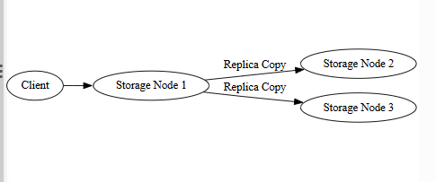─────────────────────────────────────────────────────────────────
Data storage and retrieval in distributed systems require careful management of partitioning, replication, synchronization, and fault tolerance to ensure high performance, consistency, and reliability.
─────────────────────────────────────────────────────────────────

➤ Communication Overhead

Communication Overhead in Distributed Systems
Communication overhead refers to the extra time, processing effort, and network resources required for exchanging data and control messages among nodes in a distributed system. Since distributed systems do not share memory, all coordination and data transfer occur through network-based message passing.
This overhead is a major factor influencing system performance, scalability, and efficiency.
─────────────────────────────────────────────────────────────────
Nature of Communication in Distributed Systems
Each node operates independently and interacts with others by sending and receiving messages. These messages may include:
- Data transfers
- Task coordination signals
- Synchronization messages
- Status updates
- Acknowledgements
Every such exchange consumes network bandwidth and processing time.
─────────────────────────────────────────────────────────────────
Major Causes of Communication Overhead
1. Network Latency
Messages take time to travel across network links due to propagation delays, routing, and processing at intermediate nodes. High latency increases task completion time.
─────────────────────────────────────────────────────────────────
2. Limited Bandwidth
When large volumes of data are transmitted, network capacity may become saturated. This results in congestion, delays, and packet loss.
─────────────────────────────────────────────────────────────────
3. High Message Frequency
Distributed algorithms often require frequent coordination. Excessive message exchange increases processing load and slows execution.
─────────────────────────────────────────────────────────────────
4. Data Encoding and Decoding
Before transmission, data must be serialized into network-compatible formats and reconstructed at the receiver side. This consumes CPU resources and adds delay.
─────────────────────────────────────────────────────────────────
5. Synchronization Wait Times
Nodes may pause execution while waiting for responses from other nodes, reducing parallel efficiency.
─────────────────────────────────────────────────────────────────
Impact on System Performance
- Increased execution time
- Reduced throughput
- Network congestion
- Lower resource utilization efficiency
- Higher operational cost
─────────────────────────────────────────────────────────────────
Techniques to Minimize Communication Overhead
- Reducing unnecessary message exchange
- Aggregating multiple messages into batches
- Compressing transmitted data
- Using efficient network protocols
- Caching frequently accessed data locally
- Optimizing task placement near data sources
─────────────────────────────────────────────────────────────────
Communication overhead is an inherent challenge in distributed computing. Effective system design focuses on minimizing communication while maximizing parallel computation to achieve high performance and scalability.
─────────────────────────────────────────────────────────────────
Synchronization in Distributed Systems
Synchronization is the process of coordinating multiple distributed processes or nodes to ensure correct and consistent access to shared resources and data. Since distributed systems operate concurrently without a global clock or shared memory, synchronization becomes essential to maintain system correctness, data integrity, and proper execution order.
Without synchronization, distributed systems may suffer from race conditions, inconsistent data states, deadlocks, and lost updates.
─────────────────────────────────────────────────────────────────
Need for Synchronization in Distributed Computing
Distributed systems involve:
- Multiple nodes executing tasks simultaneously
- Shared data across networked machines
- Concurrent read and write operations
Synchronization ensures:
- Only one process modifies shared data at a time
- Correct sequence of operations
- Consistency among replicas
- Proper coordination between tasks
─────────────────────────────────────────────────────────────────
Major Synchronization Challenges
1. Absence of Global Clock
Each node has its own local clock, making it difficult to determine exact event ordering.
2. Network Delays
Messages may arrive late, out of order, or be lost.
3. Concurrent Access
Multiple processes may access the same data simultaneously.
4. Partial Failures
Some nodes may crash while others continue operating.
─────────────────────────────────────────────────────────────────
Common Synchronization Techniques
1. Distributed Locks
A distributed lock ensures that only one node can access a shared resource at a time.
Steps:
- A node requests a lock
- If available, access is granted
- Other nodes must wait
- Lock is released after use
This prevents conflicts and data inconsistency.
─────────────────────────────────────────────────────────────────
2. Logical Clocks
Logical clocks assign timestamps to events to maintain order of execution.
Two common types:
- Lamport timestamps
- Vector clocks
They help determine causality between distributed events.
─────────────────────────────────────────────────────────────────
3. Token-Based Synchronization
A special token circulates among nodes.
Only the node holding the token can access shared resources.
This reduces message overhead and ensures mutual exclusion.
─────────────────────────────────────────────────────────────────
4. Barrier Synchronization
All nodes must reach a specific point in execution before any can proceed further.
Used in parallel processing applications.
─────────────────────────────────────────────────────────────────
Diagram required here — Distributed Lock Coordination
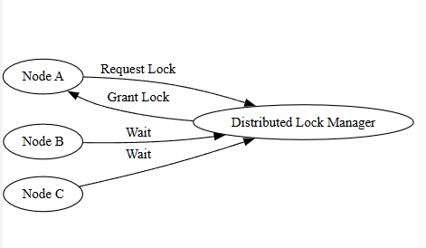─────────────────────────────────────────────────────────────────
Advantages of Synchronization
- Maintains data consistency
- Prevents race conditions
- Ensures correct execution order
- Improves reliability of distributed applications
─────────────────────────────────────────────────────────────────
Limitations
- Increases communication overhead
- May introduce delays
- Adds system complexity
─────────────────────────────────────────────────────────────────
Synchronization is a fundamental requirement in distributed systems to coordinate concurrent operations, preserve data correctness, and ensure reliable system behavior across multiple interconnected nodes.
─────────────────────────────────────────────────────────────────
Fault Tolerance in Distributed Systems
Fault tolerance is the ability of a distributed system to continue operating correctly even when some of its components fail. Since distributed systems consist of multiple independent nodes connected through networks, failures such as hardware crashes, network breakdowns, or software errors are unavoidable.
A fault-tolerant system detects failures, isolates faulty components, and recovers automatically without disrupting overall system functionality.
─────────────────────────────────────────────────────────────────
Importance of Fault Tolerance
Distributed environments are highly prone to:
- Node failures
- Network partitions
- Disk crashes
- Software bugs
Without fault tolerance, a single failure could stop the entire system. Therefore, fault tolerance ensures:
- High availability
- System reliability
- Data protection
- Continuous service
─────────────────────────────────────────────────────────────────
Types of Failures in Distributed Systems
1. Crash Failures
A node stops functioning completely and does not respond.
2. Omission Failures
Messages sent or received may be lost.
3. Timing Failures
Operations do not complete within expected time limits.
4. Byzantine Failures
Nodes behave unpredictably or maliciously by sending incorrect information.
─────────────────────────────────────────────────────────────────
Fault Tolerance Mechanisms
1. Replication
Multiple copies of data or services are maintained on different nodes.
If one node fails, another replica takes over.
Replication improves:
- Availability
- Reliability
- Data safety
─────────────────────────────────────────────────────────────────
2. Checkpointing and Recovery
System state is periodically saved (checkpointed).
If failure occurs, the system restarts from the last saved state instead of beginning from scratch.
─────────────────────────────────────────────────────────────────
3. Failure Detection
Monitoring components continuously check node health using heartbeat messages.
If a node fails to respond, it is marked as failed and recovery is initiated.
─────────────────────────────────────────────────────────────────
4. Redundancy
Extra hardware, network links, and backup servers are provided to replace failed components.
─────────────────────────────────────────────────────────────────
5. Automatic Failover
When a primary node fails, control is automatically transferred to a backup node without user intervention.
─────────────────────────────────────────────────────────────────
Diagram required here — Fault Tolerant Replication System
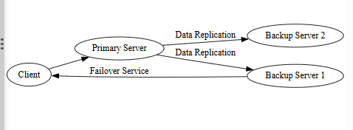─────────────────────────────────────────────────────────────────
Advantages of Fault Tolerance
- Continuous system operation
- Reduced downtime
- Improved data safety
- Higher user trust
─────────────────────────────────────────────────────────────────
Challenges
- Increased cost due to redundancy
- Additional communication overhead
- Complex system design
─────────────────────────────────────────────────────────────────
Fault tolerance is a critical feature of distributed systems that ensures reliability and availability despite frequent failures, making large-scale distributed applications practical and dependable.
─────────────────────────────────────────────────────────────────
Use Cases of AI & Data Science in Distributed Systems
The integration of Artificial Intelligence (AI) and Data Science (DS) with distributed computing enables large-scale data processing, real-time analytics, and intelligent decision-making across multiple interconnected systems. Distributed infrastructures provide the computational power and storage capacity required to handle massive datasets generated in modern applications.
─────────────────────────────────────────────────────────────────
1. Predictive Maintenance
Predictive maintenance uses AI models to analyze sensor data collected from machines distributed across factories, power plants, and industrial environments.
Distributed systems continuously gather and process real-time data such as temperature, vibration, pressure, and operational logs. Machine learning algorithms identify abnormal patterns that indicate potential equipment failures before they occur.
This approach reduces unexpected breakdowns, minimizes downtime, lowers maintenance costs, and improves equipment lifespan.
─────────────────────────────────────────────────────────────────
2. Fraud Detection
Financial institutions process millions of transactions per second across geographically distributed servers. Distributed AI systems analyze transaction streams in real time to detect unusual behaviors such as unauthorized purchases, identity theft, and money laundering.
Data science techniques identify hidden patterns and anomalies while distributed infrastructure ensures high-speed processing and scalability.
─────────────────────────────────────────────────────────────────
3. Intelligent Transportation Systems
Traffic sensors, GPS devices, cameras, and smart signals generate enormous amounts of data across cities.
Distributed AI platforms process this data to:
- Predict traffic congestion
- Optimize traffic signal timing
- Suggest shortest routes
- Improve road safety
This leads to reduced travel time, lower fuel consumption, and improved urban mobility.
─────────────────────────────────────────────────────────────────
4. Supply Chain Optimization
Modern supply chains involve warehouses, suppliers, logistics centers, and retail outlets across different regions.
Distributed data systems collect inventory levels, shipment data, and customer demand patterns. AI models analyze this information to forecast demand, optimize stock levels, reduce delivery delays, and minimize operational costs.
─────────────────────────────────────────────────────────────────
5. Energy Management
Smart grids collect real-time energy consumption data from millions of households and industries.
Distributed AI systems analyze usage patterns to:
- Balance energy supply and demand
- Detect power theft
- Predict peak load times
- Optimize renewable energy integration
This improves efficiency and reduces energy wastage.
─────────────────────────────────────────────────────────────────
6. Healthcare and Medical Diagnostics
Hospitals and medical centers store patient records, imaging data, and real-time health metrics across distributed databases.
AI algorithms analyze this data to:
- Detect diseases early
- Interpret medical images
- Predict patient risks
- Support clinical decision-making
Distributed systems enable fast processing while maintaining availability and reliability.
─────────────────────────────────────────────────────────────────
7. Customer Behavior Analysis
E-commerce platforms collect massive data related to browsing habits, purchases, reviews, and interactions.
Distributed data science systems analyze this data to:
- Predict customer preferences
- Recommend products
- Personalize user experience
- Improve marketing strategies
─────────────────────────────────────────────────────────────────
8. Natural Language Processing (NLP)
Large language models require enormous datasets and computing power.
Distributed systems train and deploy NLP models for:
- Chatbots
- Language translation
- Sentiment analysis
- Voice assistants
Parallel processing significantly reduces training time and enables real-time language services.
─────────────────────────────────────────────────────────────────
The combination of AI, data science, and distributed computing powers modern intelligent applications by enabling scalable, reliable, and high-speed data-driven solutions across industries.
─────────────────────────────────────────────────────────────────
Predictive Maintenance in Distributed Systems using AI & Data Science
Predictive maintenance is an advanced maintenance strategy that uses Artificial Intelligence and Data Science techniques to predict equipment failures before they actually occur. Instead of performing maintenance at fixed time intervals or after breakdowns, predictive maintenance analyzes real-time and historical data to determine the health condition of machines.
In distributed systems, data is collected from multiple machines located across different sites and processed across distributed computing nodes, enabling large-scale monitoring and intelligent decision-making.
─────────────────────────────────────────────────────────────────
Working Principle of Predictive Maintenance
Machines are equipped with sensors that continuously record operational parameters such as:
- Temperature
- Vibration
- Pressure
- Energy consumption
- Sound levels
This sensor data is transmitted to distributed storage systems where it is processed in parallel.
AI and machine learning models analyze this massive data to identify abnormal patterns, performance degradation, and early signs of failure.
Based on predictions, maintenance actions are scheduled before a breakdown occurs.
─────────────────────────────────────────────────────────────────
Diagram required here — Predictive Maintenance Architecture
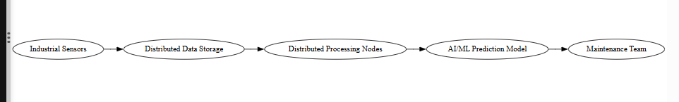─────────────────────────────────────────────────────────────────
Role of Distributed Computing in Predictive Maintenance
Distributed systems provide:
- Real-time data collection from many machines
- Scalable storage for sensor data
- Parallel processing for fast analytics
- Fault-tolerant monitoring infrastructure
This allows continuous and reliable prediction even at large industrial scale.
─────────────────────────────────────────────────────────────────
Applications of Predictive Maintenance
- Manufacturing plants to monitor machinery health
- Power plants for turbine and generator monitoring
- Transportation systems for vehicle and engine diagnostics
- Oil and gas industries for pipeline and equipment safety
- Data centers for server performance monitoring
─────────────────────────────────────────────────────────────────
Advantages
- Prevents unexpected failures
- Reduces maintenance costs
- Increases equipment lifespan
- Improves operational efficiency
- Enhances safety
─────────────────────────────────────────────────────────────────
Challenges
- Handling massive real-time data streams
- Ensuring data accuracy
- Model training complexity
- Communication overhead
─────────────────────────────────────────────────────────────────
Predictive maintenance using AI and distributed computing transforms traditional maintenance approaches by enabling proactive, data-driven decision-making, improving reliability and efficiency in industrial systems.
─────────────────────────────────────────────────────────────────
Healthcare and Medical Diagnostics using AI & Data Science in Distributed Systems
Healthcare and medical diagnostics involve the analysis of large volumes of patient data, medical images, clinical records, and real-time health monitoring information. Artificial Intelligence and Data Science integrated with distributed computing enable efficient processing, storage, and analysis of this massive and complex data across hospitals and healthcare centers.
Distributed systems provide scalability, reliability, and high computational power required for modern intelligent healthcare applications.
─────────────────────────────────────────────────────────────────
Data Collection in Healthcare Systems
Healthcare data is generated from multiple sources such as:
- Electronic health records (EHRs)
- Medical imaging systems (X-rays, MRI, CT scans)
- Wearable health devices
- Laboratory reports
- Real-time patient monitoring systems
This data is stored across distributed databases located in different hospitals and medical centers.
─────────────────────────────────────────────────────────────────
Role of Distributed Computing
Distributed computing allows:
- Storage of massive medical datasets across nodes
- Parallel processing of medical images and patient records
- Real-time analytics for emergency care
- High availability of critical health data
It ensures fast access and fault tolerance, which are essential in healthcare environments.
─────────────────────────────────────────────────────────────────
AI and Data Science Techniques Used
- Machine learning models for disease prediction
- Deep learning for medical image analysis
- Pattern recognition for symptom detection
- Predictive analytics for patient risk assessment
- Natural language processing for medical reports
These techniques require large computational resources, which distributed systems efficiently provide.
─────────────────────────────────────────────────────────────────
Key Applications
1. Disease Diagnosis
AI models analyze medical images and patient data to detect diseases such as cancer, heart disorders, and neurological conditions at early stages.
─────────────────────────────────────────────────────────────────
2. Medical Imaging Analysis
Distributed deep learning systems process thousands of scans in parallel to identify tumors, fractures, and abnormalities with high accuracy.
─────────────────────────────────────────────────────────────────
3. Remote Patient Monitoring
Wearable sensors transmit real-time health data to distributed platforms where AI detects irregularities and alerts medical professionals.
─────────────────────────────────────────────────────────────────
4. Personalized Treatment Planning
Data science analyzes patient history and genetic data to recommend customized treatment strategies.
─────────────────────────────────────────────────────────────────
5. Hospital Resource Optimization
AI predicts patient inflow, bed availability, and staff requirements for efficient hospital management.
─────────────────────────────────────────────────────────────────
Diagram required here — Distributed AI Healthcare System

─────────────────────────────────────────────────────────────────
Advantages
- Faster and more accurate diagnosis
- Improved patient outcomes
- Real-time medical decision support
- Efficient handling of big medical data
- High system reliability
─────────────────────────────────────────────────────────────────
Challenges
- Data privacy and security concerns
- Integration of heterogeneous medical data
- High infrastructure cost
- Regulatory compliance
─────────────────────────────────────────────────────────────────
The use of AI and data science in distributed healthcare systems enhances diagnostic accuracy, enables real-time monitoring, and improves overall healthcare efficiency, making modern medical services more intelligent and accessible.
─────────────────────────────────────────────────────────────────
Fraud Detection using AI & Data Science in Distributed Systems
Fraud detection is the process of identifying unauthorized, illegal, or suspicious activities within financial transactions, insurance claims, online payments, banking operations, and e-commerce platforms. Modern fraud detection systems rely heavily on Artificial Intelligence (AI) and Data Science techniques operating over distributed computing infrastructures to analyze massive volumes of transaction data in real time.
Distributed systems are essential because fraud detection requires processing millions of transactions per second across geographically distributed servers.
─────────────────────────────────────────────────────────────────
Need for Distributed Computing in Fraud Detection
Financial and digital platforms generate:
- High-volume transaction streams
- Real-time payment requests
- User behavioral data
- Historical transaction records
Processing this large-scale data using a single machine is not feasible. Distributed computing enables:
- Parallel analysis of transaction streams
- Scalable storage of historical records
- Real-time anomaly detection
- High availability and fault tolerance
─────────────────────────────────────────────────────────────────
Working Mechanism of Fraud Detection System
- 1. Transaction data is collected from multiple sources such as banks, ATMs, online platforms, and mobile applications.
- 2. The data is stored across distributed databases.
- 3. AI models analyze transaction patterns, user behavior, and historical trends.
- 4. Suspicious patterns are detected using machine learning algorithms.
- 5. Alerts are generated for further verification or automatic blocking.
─────────────────────────────────────────────────────────────────
Diagram required here — Distributed Fraud Detection Architecture
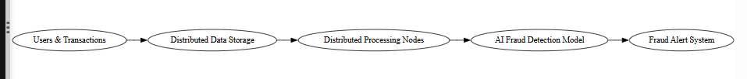─────────────────────────────────────────────────────────────────
AI & Data Science Techniques Used
- Supervised learning for classification of fraudulent vs legitimate transactions
- Unsupervised learning for anomaly detection
- Neural networks for complex pattern recognition
- Real-time stream analytics
- Behavioral analytics for user profiling
─────────────────────────────────────────────────────────────────
Types of Fraud Detected
- Credit card fraud
- Insurance fraud
- Identity theft
- Online transaction fraud
- Money laundering
─────────────────────────────────────────────────────────────────
Advantages of Distributed Fraud Detection
- Real-time detection of suspicious activity
- High scalability for growing transaction volumes
- Improved accuracy through large-scale data analysis
- Reduced financial losses
- Continuous system availability
─────────────────────────────────────────────────────────────────
Challenges
- High communication overhead
- Maintaining data privacy
- Handling false positives
- Model training complexity
- Ensuring low latency
─────────────────────────────────────────────────────────────────
Fraud detection systems integrated with AI and distributed computing provide scalable, real-time, and reliable mechanisms to identify fraudulent activities, protect financial systems, and enhance trust in digital platforms.
─────────────────────────────────────────────────────────────────
Data Consistency in Distributed Systems
Data consistency refers to the property that ensures all users and processes in a distributed system see the same and correct data at any given time, even though the data is stored across multiple nodes. Since distributed systems maintain multiple copies (replicas) of data for reliability and performance, keeping these replicas synchronized is a major challenge.
When one copy of data is updated, the change must be reflected across all other copies to prevent conflicting or outdated information.
─────────────────────────────────────────────────────────────────
Why Data Consistency is Important
In distributed environments:
- Multiple users may access the same data simultaneously
- Data may be replicated across locations
- Updates may occur concurrently
Without consistency, systems may produce incorrect results, financial errors, medical mistakes, or system failures.
─────────────────────────────────────────────────────────────────
Causes of Inconsistency
1. Replication Delays
Updates made on one node may take time to propagate to others, causing temporary mismatches.
2. Network Failures
Message loss or delays can prevent timely update synchronization.
3. Concurrent Updates
Multiple nodes modifying the same data at the same time can lead to conflicts.
4. Node Failures
Failed nodes may miss updates and return outdated data.
─────────────────────────────────────────────────────────────────
Methods to Maintain Data Consistency
1. Synchronous Updates
All replicas are updated at the same time before confirming the operation.
This ensures strong consistency but increases latency.
─────────────────────────────────────────────────────────────────
2. Asynchronous Updates
Updates are propagated gradually to other nodes.
This improves performance but may temporarily cause inconsistency.
─────────────────────────────────────────────────────────────────
3. Locking Mechanisms
Ensure only one process can update data at a time.
─────────────────────────────────────────────────────────────────
4. Consensus Protocols
Nodes agree on updates before applying changes to maintain correctness.
─────────────────────────────────────────────────────────────────
Trade-off Between Consistency and Performance
Maintaining strong consistency often increases:
- Communication overhead
- Response time
- System complexity
Therefore, many systems allow temporary inconsistency for higher performance and scalability.
─────────────────────────────────────────────────────────────────
Diagram required here — Data Replication and Consistency Flow
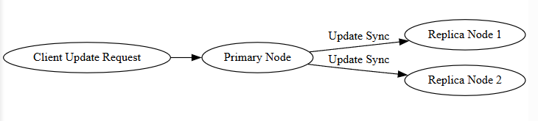─────────────────────────────────────────────────────────────────
Data consistency is a critical aspect of distributed systems that ensures reliability and correctness of information across multiple nodes while balancing system performance and scalability.
─────────────────────────────────────────────────────────────────
Intelligent Transportation Systems using AI & Data Science in Distributed Computing
Intelligent Transportation Systems (ITS) are advanced systems that use Artificial Intelligence, Data Science, and distributed computing to improve transportation efficiency, safety, and sustainability. These systems collect real-time data from various transportation sources and process it across distributed infrastructures to support smart decision-making.
Distributed computing is essential in ITS because transportation data is generated continuously across large geographic areas and requires fast, scalable processing.
─────────────────────────────────────────────────────────────────
Data Sources in Intelligent Transportation Systems
ITS collects data from:
- Traffic sensors and road cameras
- GPS devices in vehicles
- Smart traffic lights
- Public transport systems
- Weather monitoring stations
These sources generate massive real-time data streams distributed across cities and highways.
─────────────────────────────────────────────────────────────────
Role of Distributed Computing
Distributed systems enable:
- Real-time data collection across locations
- Scalable storage of traffic data
- Parallel processing for fast analytics
- High availability and reliability
- Fault tolerance for critical infrastructure
─────────────────────────────────────────────────────────────────
Working Mechanism
- 1. Data is continuously collected from sensors and vehicles.
- 2. The data is transmitted to distributed data centers.
- 3. AI models analyze traffic patterns, congestion levels, and accident risks.
- 4. Predictions and optimization decisions are generated.
- 5. Traffic signals, route suggestions, and alerts are updated in real time.
─────────────────────────────────────────────────────────────────
Diagram required here — Distributed ITS Architecture
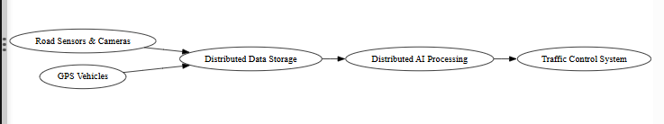─────────────────────────────────────────────────────────────────
Applications
- Real-time traffic congestion management
- Smart traffic signal control
- Accident detection and prevention
- Route optimization for vehicles
- Public transport scheduling
- Emergency response coordination
─────────────────────────────────────────────────────────────────
Advantages
- Reduced traffic congestion
- Improved road safety
- Lower fuel consumption
- Faster travel times
- Efficient urban mobility
─────────────────────────────────────────────────────────────────
Challenges
- Handling massive real-time data streams
- Network reliability
- Data privacy concerns
- Infrastructure cost
- System complexity
─────────────────────────────────────────────────────────────────
Intelligent Transportation Systems powered by AI and distributed computing enable smart mobility solutions by processing large-scale real-time data efficiently, improving transportation efficiency, safety, and sustainability.
─────────────────────────────────────────────────────────────────
Supply Chain Optimization using AI & Data Science in Distributed Systems
Supply chain optimization focuses on improving the efficiency, reliability, and cost-effectiveness of the flow of goods, information, and finances across suppliers, manufacturers, warehouses, transportation networks, and retailers. Artificial Intelligence and Data Science integrated with distributed computing enable large-scale data processing and real-time decision-making across geographically dispersed supply chain components.
Distributed systems are essential because modern supply chains generate massive data from multiple locations simultaneously.
─────────────────────────────────────────────────────────────────
Data Sources in Supply Chains
Supply chain operations produce data from:
- Inventory management systems
- Warehouse sensors and RFID tags
- Transportation and logistics platforms
- Sales and demand records
- Supplier and procurement databases
This data is stored across distributed databases in different locations.
─────────────────────────────────────────────────────────────────
Role of Distributed Computing
Distributed computing provides:
- Scalable storage for supply chain data
- Parallel processing of logistics information
- Real-time tracking of shipments
- High availability of operational data
- Fault-tolerant infrastructure
It enables efficient coordination across global supply networks.
─────────────────────────────────────────────────────────────────
AI & Data Science Techniques Used
- Demand forecasting using machine learning
- Route optimization algorithms
- Inventory optimization models
- Predictive analytics for supplier risks
- Pattern recognition for bottleneck detection
─────────────────────────────────────────────────────────────────
Working Process
- 1. Data is collected from warehouses, suppliers, and transportation systems.
- 2. Distributed storage systems manage large-scale operational data.
- 3. AI models analyze trends and predict demand and delays.
- 4. Optimization algorithms suggest inventory levels, shipping routes, and schedules.
- 5. Decisions are implemented in real time across the supply chain.
─────────────────────────────────────────────────────────────────
Diagram required here — Distributed Supply Chain Optimization System
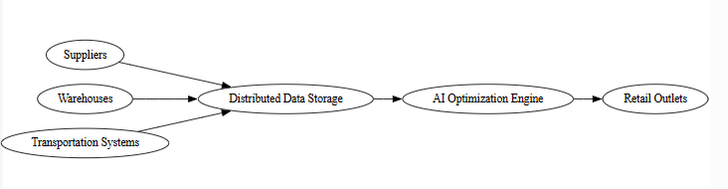─────────────────────────────────────────────────────────────────
Applications
- Demand prediction and inventory planning
- Shipment tracking and delivery optimization
- Supplier performance monitoring
- Cost reduction strategies
- Risk management
─────────────────────────────────────────────────────────────────
Advantages
- Reduced operational costs
- Improved delivery speed
- Better inventory utilization
- Enhanced customer satisfaction
- Real-time decision support
─────────────────────────────────────────────────────────────────
Challenges
- Integration of heterogeneous data sources
- High communication overhead
- Data security concerns
- System complexity
─────────────────────────────────────────────────────────────────
Supply chain optimization using AI and distributed computing enables intelligent, data-driven coordination of global supply networks, improving efficiency, reliability, and business performance.
─────────────────────────────────────────────────────────────────
Energy Management using AI & Data Science in Distributed Systems
Energy management refers to the intelligent monitoring, control, and optimization of energy production, distribution, and consumption. Modern energy systems such as smart grids generate massive real-time data from distributed sources. Artificial Intelligence (AI) and Data Science techniques combined with distributed computing enable efficient analysis and optimization of this large-scale energy data.
Distributed systems are essential because energy infrastructure is geographically dispersed and continuously generates high-volume data streams.
─────────────────────────────────────────────────────────────────
Data Sources in Energy Management Systems
Energy management systems collect data from:
- Smart meters in households and industries
- Power generation plants
- Renewable energy sources (solar panels, wind turbines)
- Transmission and distribution networks
- Grid sensors and monitoring devices
This data is stored and processed across distributed nodes.
─────────────────────────────────────────────────────────────────
Role of Distributed Computing
Distributed computing enables:
- Scalable storage of energy consumption data
- Parallel processing of large datasets
- Real-time monitoring of grid performance
- Fault tolerance for critical infrastructure
- High availability of system data
It supports continuous monitoring across multiple geographic locations.
─────────────────────────────────────────────────────────────────
AI & Data Science Techniques Used
- Load forecasting using machine learning
- Demand prediction models
- Optimization algorithms for energy distribution
- Anomaly detection for fault identification
- Renewable energy integration forecasting
─────────────────────────────────────────────────────────────────
Working Mechanism
- 1. Energy usage and generation data are continuously collected from smart devices and sensors.
- 2. Data is transmitted to distributed storage systems.
- 3. AI models analyze usage patterns and predict demand.
- 4. Optimization algorithms balance supply and demand.
- 5. Control systems adjust energy distribution accordingly.
─────────────────────────────────────────────────────────────────
Diagram required here — Distributed Energy Management System
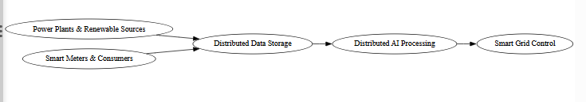─────────────────────────────────────────────────────────────────
Applications
- Smart grid management
- Peak load prediction
- Renewable energy optimization
- Power outage detection
- Energy theft detection
─────────────────────────────────────────────────────────────────
Advantages
- Efficient energy utilization
- Reduced operational costs
- Improved grid reliability
- Better integration of renewable energy
- Real-time energy monitoring
─────────────────────────────────────────────────────────────────
Challenges
- Handling massive real-time data streams
- Communication delays
- Cybersecurity risks
- Infrastructure complexity
─────────────────────────────────────────────────────────────────
Energy management systems powered by AI and distributed computing enable intelligent, scalable, and reliable control of modern energy networks, ensuring optimal utilization and sustainability.
─────────────────────────────────────────────────────────────────
Customer Behavior Analysis using AI & Data Science in Distributed Systems
Customer behavior analysis involves studying customer interactions, purchasing patterns, preferences, and engagement data to understand decision-making behavior. Artificial Intelligence (AI) and Data Science techniques applied over distributed computing systems enable large-scale processing of customer data generated from multiple digital platforms.
Modern e-commerce platforms, social media applications, and online services generate massive volumes of user data. Distributed systems provide the scalability and computational power required to analyze this data efficiently and in real time.
─────────────────────────────────────────────────────────────────
Data Sources for Customer Behavior Analysis
Customer-related data is collected from:
- Online transactions
- Website browsing history
- Mobile application usage
- Social media interactions
- Product reviews and ratings
- Clickstream data
This data is stored across distributed databases due to its volume and variety.
─────────────────────────────────────────────────────────────────
Role of Distributed Computing
Distributed computing enables:
- Storage of large customer datasets across multiple nodes
- Parallel processing of behavioral data
- Real-time analytics for recommendations
- Fault tolerance and high availability
- Scalability to handle millions of users
─────────────────────────────────────────────────────────────────
AI & Data Science Techniques Used
- Machine learning for purchase prediction
- Recommendation algorithms (collaborative filtering, content-based filtering)
- Clustering for customer segmentation
- Sentiment analysis for review analysis
- Predictive modeling for churn prediction
These techniques require high computational resources, efficiently provided by distributed systems.
─────────────────────────────────────────────────────────────────
Working Process
- 1. Customer interaction data is continuously collected.
- 2. Data is stored in distributed storage systems.
- 3. Distributed processing nodes analyze patterns and trends.
- 4. AI models generate insights and predictions.
- 5. Results are used for personalized marketing, recommendations, and strategic decisions.
─────────────────────────────────────────────────────────────────
Diagram required here — Distributed Customer Behavior Analysis System
─────────────────────────────────────────────────────────────────
Applications
- Personalized product recommendations
- Targeted advertising
- Customer segmentation
- Demand forecasting
- Customer retention strategies
- Sentiment analysis
─────────────────────────────────────────────────────────────────
Advantages
- Improved customer experience
- Increased sales and revenue
- Data-driven marketing strategies
- Real-time personalization
- Competitive advantage
─────────────────────────────────────────────────────────────────
Challenges
- Handling high-volume streaming data
- Data privacy and regulatory compliance
- Integration of structured and unstructured data
- High infrastructure and processing cost
─────────────────────────────────────────────────────────────────
Customer behavior analysis powered by AI and distributed computing enables businesses to transform massive customer data into actionable insights, improving personalization, operational efficiency, and strategic decision-making.
─────────────────────────────────────────────────────────────────
Natural Language Processing (NLP) using AI & Data Science in Distributed Systems
Natural Language Processing (NLP) is a branch of artificial intelligence that enables computers to understand, interpret, analyze, and generate human language in the form of text and speech. NLP applications require processing extremely large datasets such as documents, social media content, conversations, and web data.
Distributed computing provides the necessary computational power and storage to handle large-scale NLP workloads efficiently by processing data in parallel across multiple nodes.
─────────────────────────────────────────────────────────────────
Need for Distributed Computing in NLP
NLP systems deal with:
- Massive text corpora
- Real-time language streams
- Complex deep learning models
- High memory and processing requirements
Single machines cannot efficiently process such large workloads. Distributed systems enable:
- Parallel data processing
- Faster model training
- Scalable storage
- High availability and fault tolerance
─────────────────────────────────────────────────────────────────
Working Mechanism of Distributed NLP Systems
- 1. Large volumes of text data are collected from multiple sources such as websites, social media platforms, and databases.
- 2. Data is stored across distributed storage systems.
- 3. Preprocessing tasks such as tokenization, cleaning, and normalization are performed in parallel.
- 4. AI models such as neural networks analyze language patterns.
- 5. Results are generated in the form of predictions, translations, summaries, or responses.
─────────────────────────────────────────────────────────────────
Diagram required here — Distributed NLP Processing System
─────────────────────────────────────────────────────────────────
AI & Data Science Techniques Used
- Tokenization and text preprocessing
- Word embeddings and language representations
- Deep learning models such as recurrent and transformer networks
- Sentiment analysis algorithms
- Topic modeling and classification
─────────────────────────────────────────────────────────────────
Applications of NLP in Distributed Systems
- Chatbots and virtual assistants
- Language translation systems
- Speech recognition platforms
- Sentiment analysis on social media
- Document summarization
- Search engines
─────────────────────────────────────────────────────────────────
Advantages
- Fast processing of massive language datasets
- Scalable model training
- Real-time language understanding
- Improved accuracy through large data analysis
- Reliable service availability
─────────────────────────────────────────────────────────────────
Challenges
- High computational cost
- Communication overhead
- Data privacy issues
- Model synchronization complexity
─────────────────────────────────────────────────────────────────
Natural Language Processing integrated with distributed computing enables large-scale language understanding systems capable of handling massive data efficiently, forming the backbone of modern intelligent communication technologies.
─────────────────────────────────────────────────────────────────
Unit I — Introduction to Distributed Computing (Complete Summary)
Distributed computing is a computing paradigm in which multiple independent computers (nodes) work together over a network to perform tasks as a single system. It improves performance, scalability, reliability, and resource utilization by distributing workload and data across machines.
Key Characteristics of Distributed Systems
Distributed systems support resource sharing, allowing hardware, software, and data to be accessed across nodes. They enable concurrency through parallel execution of tasks. Scalability allows system expansion by adding more nodes without performance loss. Fault tolerance ensures continued operation despite failures using replication and redundancy. Transparency hides system complexity from users. They also support heterogeneity, openness, and strong security mechanisms.
Major Issues in Distributed Systems
Data storage and retrieval face challenges such as consistency maintenance, synchronization of replicas, network latency, fault recovery, and data integrity.
Communication overhead arises due to message passing, bandwidth limitations, serialization costs, frequent coordination, and synchronization delays.
Additional challenges include synchronization of concurrent processes and fault handling across distributed nodes.
Goals of Distributed Systems
The main goals are efficient resource sharing, improved performance through parallelism, high reliability and availability, easy scalability, system transparency, flexibility across heterogeneous platforms, and cost-effective computing.
AI & Data Science in Distributed Computing
Distributed systems provide the infrastructure required to process massive datasets and complex AI workloads. Computational tasks are divided and executed in parallel to speed up processing. Large volumes of data are stored in distributed storage systems and processed simultaneously using parallel frameworks. Key challenges include consistency, communication overhead, synchronization, fault tolerance, and load balancing.
Major Use Cases of AI & DS in Distributed Systems
• Predictive Maintenance – real-time machine health monitoring and failure prediction
• Healthcare & Medical Diagnostics – large-scale medical data analysis and AI-driven diagnosis
• Fraud Detection – real-time anomaly detection in financial systems
• Intelligent Transportation Systems – traffic prediction and smart mobility management
• Supply Chain Optimization – demand forecasting and logistics efficiency
• Energy Management – smart grid monitoring and optimization
• Customer Behavior Analysis – personalization and recommendation systems
• Natural Language Processing – large-scale language model training and real-time language services
─────────────────────────────────────────────────────────────────
UNIT II — Distributed Data Management & Storage
Distributed Data Management & Storage
Distributed Data Management and Storage deals with techniques and technologies used to store, organize, manage, replicate, and retrieve data across multiple interconnected machines. In distributed systems, data is not stored in a single centralized location but is partitioned and replicated across nodes to ensure scalability, availability, and reliability.
Efficient data management is essential for large-scale applications such as cloud computing, big data analytics, AI systems, and enterprise platforms.
─────────────────────────────────────────────────────────────────
1. Distributed Data Storage
In distributed environments, data is divided into smaller parts called partitions or shards. Each partition is stored on different machines to distribute load and improve scalability.
To prevent data loss and improve reliability, copies of data are stored on multiple nodes using replication techniques.
Key objectives of distributed storage include:
- Scalability
- High availability
- Fault tolerance
- Efficient data access
- Load balancing
─────────────────────────────────────────────────────────────────
2. Distributed File Systems
Distributed file systems manage storage across multiple nodes while presenting a unified file system interface to users.
They handle:
- Data partitioning
- Replication
- Fault recovery
- Data consistency
- Access control
Two important distributed file systems are:
Hadoop Distributed File System (HDFS)
HDFS is designed for storing large datasets across commodity hardware. It follows a master–slave architecture consisting of:
- NameNode (metadata manager)
- DataNodes (actual data storage)
Features:
- High fault tolerance
- Large block storage
- Data replication
- Optimized for batch processing
─────────────────────────────────────────────────────────────────
Google File System (GFS)
GFS is a scalable distributed file system developed by Google for large-scale data processing.
It consists of:
- Master node
- Chunk servers
Features:
- Large chunk size
- High throughput
- Automatic fault detection
- Efficient replication
─────────────────────────────────────────────────────────────────
Diagram required here — Distributed File System Architecture
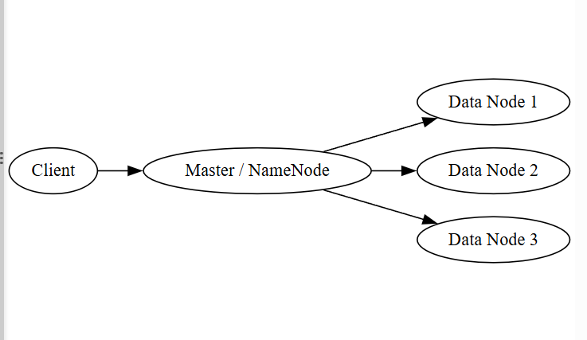─────────────────────────────────────────────────────────────────
3. Data Replication
Replication ensures multiple copies of data are stored across nodes to improve reliability and availability.
Types include:
- Eager (synchronous) replication
- Lazy (asynchronous) replication
- Quorum-based replication
- Consensus-based replication
- Selective replication
Replication improves fault tolerance but increases communication overhead.
─────────────────────────────────────────────────────────────────
4. Consistency Models
Consistency models define rules that determine how updates are visible across replicas.
Common consistency models include:
- Strong consistency
- Eventual consistency
- Read-your-writes consistency
- Causal consistency
- Consistent prefix consistency
A trade-off exists between consistency, availability, and performance.
─────────────────────────────────────────────────────────────────
5. Distributed Data Indexing & Retrieval
To efficiently locate data stored across multiple nodes, indexing mechanisms are required.
Techniques include:
- Distributed Hash Tables (DHTs)
- Distributed inverted indexing
- Range-based partitioning
- Content-based indexing
- Peer-to-peer indexing
- Hybrid indexing approaches
These methods improve search speed and retrieval efficiency in large-scale systems.
─────────────────────────────────────────────────────────────────
6. Message Brokers and Stream Processing
Message brokers manage communication between distributed components by enabling asynchronous message passing.
Stream processing systems analyze real-time data streams continuously.
These technologies support scalable and reliable data pipelines.
─────────────────────────────────────────────────────────────────
7. Edge Computing
Edge computing moves data processing closer to the data source instead of relying entirely on centralized data centers.
Benefits:
- Reduced latency
- Lower bandwidth usage
- Real-time processing
- Improved reliability
─────────────────────────────────────────────────────────────────
Distributed Data Management and Storage ensures scalable, reliable, and efficient handling of large datasets across distributed infrastructures, forming the backbone of modern cloud platforms and big data systems.
─────────────────────────────────────────────────────────────────
Overview of Distributed Computing Frameworks & Technologies
Distributed computing frameworks and technologies provide the software infrastructure required to design, manage, and operate large-scale distributed systems. They enable coordination among multiple nodes, efficient task execution, reliable data storage, parallel processing, fault tolerance, and real-time communication.
These frameworks abstract system complexity and allow developers to build scalable, high-performance distributed applications.
─────────────────────────────────────────────────────────────────
1. Parallel Computing Frameworks
Parallel computing focuses on executing multiple computations simultaneously by dividing tasks across processors or machines.
Key concepts include:
- Task decomposition
- Data partitioning
- Concurrent execution
- Result aggregation
Parallel frameworks enable high-speed computation in scientific simulations, big data analytics, and AI model training.
─────────────────────────────────────────────────────────────────
2. Distributed Computing Models
Distributed computing models define how computation and data are organized across nodes.
Common models include:
- Client–server model
- Peer-to-peer model
- Cluster-based model
- Cloud-based model
These models determine communication patterns, workload distribution, and system scalability.
─────────────────────────────────────────────────────────────────
3. Message Passing Technologies
Message passing is the primary communication mechanism in distributed systems.
Nodes exchange:
- Data messages
- Control signals
- Synchronization information
Message passing frameworks provide reliable, ordered, and scalable communication between distributed components.
─────────────────────────────────────────────────────────────────
4. Distributed File Systems
Distributed file systems store large datasets across multiple machines while appearing as a single unified storage system.
They manage:
- Data partitioning
- Replication
- Fault recovery
- Consistency
This enables scalable and reliable data storage for big data and cloud applications.
─────────────────────────────────────────────────────────────────
5. Cluster Computing and Cloud Platforms
Cluster computing connects multiple machines in a local or wide-area network to act as a single powerful system.
Cloud platforms provide on-demand distributed computing resources over the internet.
Features include:
- Elastic resource allocation
- Virtualized infrastructure
- Pay-per-use model
- High availability
These platforms power modern large-scale applications.
─────────────────────────────────────────────────────────────────
6. Message Brokers and Stream Processing Systems
Message brokers enable asynchronous communication between distributed components.
Stream processing systems analyze continuous data flows in real time.
They are essential for:
- Real-time analytics
- IoT systems
- Financial transaction processing
- Event-driven architectures
─────────────────────────────────────────────────────────────────
7. Edge Computing
Edge computing shifts computation closer to data sources such as sensors and mobile devices.
This reduces:
- Latency
- Bandwidth usage
- Dependence on central servers
It supports real-time applications such as autonomous systems and smart cities.
─────────────────────────────────────────────────────────────────
Distributed computing frameworks and technologies collectively provide the foundation for scalable, reliable, and high-performance systems that support modern AI, cloud computing, big data, and real-time applications.
─────────────────────────────────────────────────────────────────
Parallel Computing
Parallel computing is a computing paradigm in which multiple processors or computing units execute different parts of a program simultaneously to solve a problem faster. Instead of executing instructions sequentially on a single processor, parallel computing divides a large task into smaller subtasks that run concurrently.
It is widely used in scientific computing, artificial intelligence, big data processing, simulations, and high-performance computing systems.
─────────────────────────────────────────────────────────────────
Basic Concept
In parallel computing, a problem is decomposed into smaller independent or semi-independent parts. Each part is processed by separate processors or cores. After computation, the partial results are combined to produce the final output.
The primary goal of parallel computing is to reduce execution time and increase computational efficiency.
─────────────────────────────────────────────────────────────────
Types of Parallelism
1. Data Parallelism
The same operation is performed on different portions of the dataset simultaneously.
Example: Applying the same mathematical function to multiple elements of a large dataset.
─────────────────────────────────────────────────────────────────
2. Task Parallelism
Different tasks or operations are executed concurrently on different processors.
Example: One processor performs data preprocessing while another trains a machine learning model.
─────────────────────────────────────────────────────────────────
Architecture of Parallel Computing
Parallel systems may use:
- Multi-core processors
- Multiprocessor systems
- Graphics Processing Units (GPUs)
- Distributed clusters
─────────────────────────────────────────────────────────────────
Diagram required here — Parallel Processing Architecture
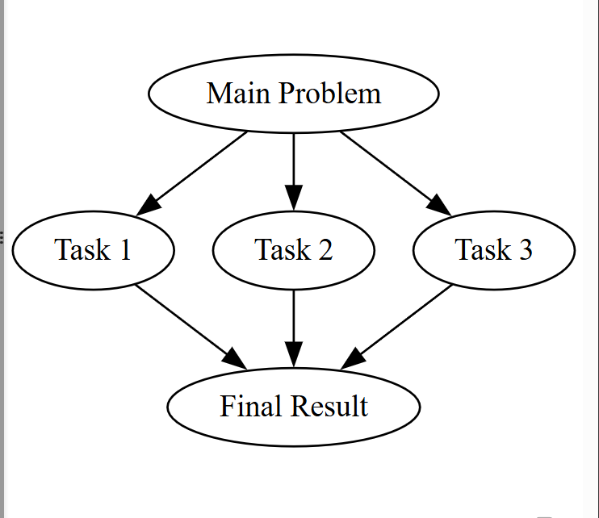─────────────────────────────────────────────────────────────────
Advantages
- Faster computation
- Improved resource utilization
- Ability to solve complex large-scale problems
- Efficient handling of big data
─────────────────────────────────────────────────────────────────
Challenges
- Task synchronization
- Communication overhead
- Load balancing issues
- Complexity in programming
─────────────────────────────────────────────────────────────────
Parallel computing is a foundational technology that enables high-performance data processing and large-scale computational tasks by executing multiple operations simultaneously.
─────────────────────────────────────────────────────────────────
Distributed Computing Models
Distributed computing models describe the structural and operational approaches used to organize computation, data storage, and communication across multiple interconnected machines. These models define how tasks are distributed, how nodes interact, and how system resources are utilized to achieve scalability, reliability, and performance.
Each model is designed to suit specific application requirements and workload characteristics.
─────────────────────────────────────────────────────────────────
1. Client–Server Model
In the client–server model, the system is divided into two main components:
- Clients, which request services or resources
- Servers, which process requests and provide responses
Servers manage centralized data storage, computation, and security, while clients handle user interactions.
This model is widely used in web applications, database systems, email services, and enterprise software.
─────────────────────────────────────────────────────────────────
Diagram required here — Client–Server Distributed Model
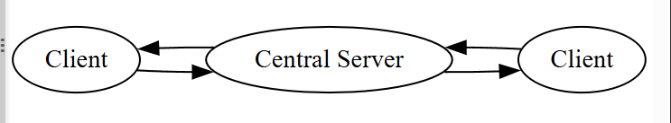─────────────────────────────────────────────────────────────────
2. Peer-to-Peer (P2P) Model
In the peer-to-peer model, all nodes are equal and act as both clients and servers. There is no central authority.
Each peer can directly share resources such as files, processing power, and data with other peers.
This model offers high scalability and fault tolerance since no single point of failure exists.
─────────────────────────────────────────────────────────────────
Diagram required here — Peer-to-Peer Distributed Model
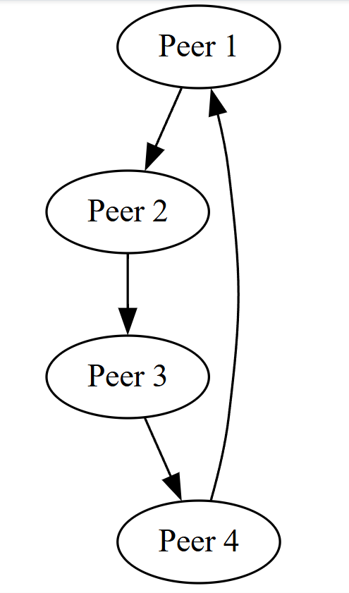─────────────────────────────────────────────────────────────────
3. Cluster-Based Model
The cluster-based model connects multiple computers within a local or wide-area network to function as a single powerful system.
Tasks are distributed among nodes and coordinated by a central scheduler.
This model is commonly used in scientific computing, data analytics, and machine learning training.
─────────────────────────────────────────────────────────────────
Diagram required here — Cluster Computing Model
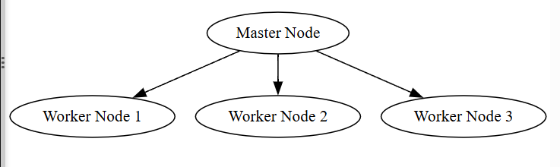─────────────────────────────────────────────────────────────────
4. Cloud-Based Model
In the cloud-based model, computing resources such as servers, storage, and applications are provided over the internet.
Users can scale resources dynamically based on demand.
Key features include:
- Virtualization
- Elastic scalability
- On-demand access
- High availability
This model powers modern distributed applications and AI services.
─────────────────────────────────────────────────────────────────
5. Hybrid Model
Hybrid distributed systems combine multiple models such as client–server with cloud or peer-to-peer architectures.
They offer flexibility, scalability, and optimized performance for complex systems.
─────────────────────────────────────────────────────────────────
Distributed computing models provide structured ways to design scalable, reliable, and high-performance systems by defining how components interact and share workloads across distributed environments.
─────────────────────────────────────────────────────────────────
Message Passing in Distributed Systems
Message passing is the primary communication mechanism used in distributed systems. Since distributed nodes do not share memory and operate independently, they communicate by explicitly sending and receiving messages over a network.
Message passing enables coordination, data exchange, synchronization, and task distribution among distributed processes.
─────────────────────────────────────────────────────────────────
Basic Concept
In distributed computing, each process runs on a separate machine with its own memory. To share information, processes send messages containing data or control information.
The communication typically follows:
- 1. A sender process constructs a message.
- 2. The message is transmitted through a network.
- 3. The receiver process receives and processes the message.
This model ensures loosely coupled interaction between system components.
─────────────────────────────────────────────────────────────────
Types of Message Passing
1. Synchronous Message Passing
In synchronous communication, the sender waits until the receiver acknowledges the message before continuing execution.
Characteristics:
- Blocking communication
- Ensures strict coordination
- Higher reliability
- May increase waiting time
─────────────────────────────────────────────────────────────────
2. Asynchronous Message Passing
In asynchronous communication, the sender does not wait for acknowledgment and continues execution immediately.
Characteristics:
- Non-blocking communication
- Improved performance
- Better scalability
- Requires buffering mechanisms
─────────────────────────────────────────────────────────────────
Communication Patterns
1. One-to-One Communication
A single sender communicates with a single receiver.
2. One-to-Many Communication
A sender broadcasts a message to multiple receivers.
3. Many-to-One Communication
Multiple senders transmit messages to a single receiver.
─────────────────────────────────────────────────────────────────
Diagram required here — Message Passing Communication
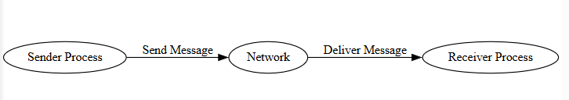─────────────────────────────────────────────────────────────────
Advantages of Message Passing
- No shared memory conflicts
- Suitable for distributed environments
- Scalable communication model
- Supports heterogeneous systems
─────────────────────────────────────────────────────────────────
Challenges
- Network latency
- Communication overhead
- Message loss or delay
- Synchronization complexity
─────────────────────────────────────────────────────────────────
Message passing forms the foundation of distributed computing by enabling reliable coordination and data exchange among independent nodes without shared memory.
─────────────────────────────────────────────────────────────────
Distributed File Systems
A Distributed File System (DFS) is a storage system that allows data to be stored across multiple machines while appearing to users as a single unified file system. It enables transparent access to files regardless of their physical location in the network.
DFS is designed to handle very large datasets, support high availability, provide fault tolerance, and allow concurrent access by multiple users and applications.
─────────────────────────────────────────────────────────────────
Objectives of Distributed File Systems
Distributed file systems aim to:
- Store massive volumes of data efficiently
- Provide fast data access
- Ensure data reliability and availability
- Support scalability
- Handle hardware failures gracefully
─────────────────────────────────────────────────────────────────
Basic Working Principle
In a DFS, large files are divided into smaller blocks or chunks. These blocks are distributed across multiple storage nodes in the system.
A central metadata manager (or master node) maintains information about:
- File names
- Block locations
- Access permissions
- Replication details
Client systems request file access through the metadata server, which directs them to the appropriate storage nodes.
─────────────────────────────────────────────────────────────────
Key Features of Distributed File Systems
1. Data Partitioning
Large files are split into smaller blocks and stored across different machines to balance storage load and improve access speed.
─────────────────────────────────────────────────────────────────
2. Data Replication
Multiple copies of each data block are stored on different nodes to ensure reliability and fault tolerance.
─────────────────────────────────────────────────────────────────
3. Fault Tolerance
If one node fails, data can still be accessed from replica nodes without interruption.
─────────────────────────────────────────────────────────────────
4. Scalability
New storage nodes can be added easily without disturbing existing data.
─────────────────────────────────────────────────────────────────
5. Transparency
Users access files as if they were stored locally, without knowing their actual physical location.
─────────────────────────────────────────────────────────────────
Diagram required here — Distributed File System Architecture
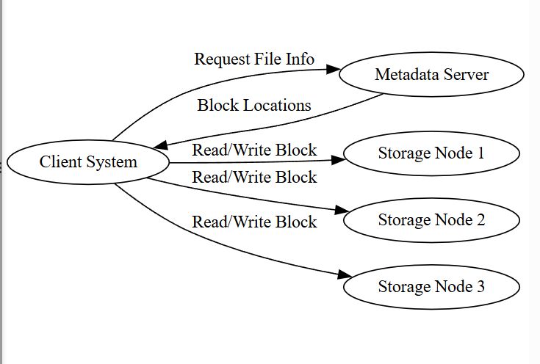─────────────────────────────────────────────────────────────────
Advantages of Distributed File Systems
- High data availability
- Improved performance through parallel access
- Large storage capacity
- Automatic recovery from failures
- Efficient resource utilization
─────────────────────────────────────────────────────────────────
Limitations
- Increased communication overhead
- Complexity in consistency management
- Metadata server bottleneck risk
- Security challenges
─────────────────────────────────────────────────────────────────
Distributed file systems form the foundation of big data platforms and cloud storage by enabling scalable, reliable, and efficient management of massive datasets across distributed infrastructures.
─────────────────────────────────────────────────────────────────
Hadoop Distributed File System (HDFS)
Hadoop Distributed File System (HDFS) is a scalable, fault-tolerant distributed storage system designed to store and manage very large datasets across clusters of commodity hardware. It is a core component of the Hadoop ecosystem and is optimized for high-throughput data access rather than low-latency operations.
HDFS is widely used in big data analytics, machine learning platforms, and cloud-based data processing systems.
─────────────────────────────────────────────────────────────────
Architecture of HDFS
HDFS follows a master–slave architecture consisting of:
- NameNode (Master)
- DataNodes (Slaves)
NameNode
The NameNode manages the file system metadata, including:
- File names and directory structure
- Location of data blocks
- Access permissions
- Replication information
It does not store actual data but keeps track of where data blocks are located.
─────────────────────────────────────────────────────────────────
DataNodes
DataNodes store the actual data blocks. They:
- Handle read and write requests
- Perform block creation and deletion
- Send heartbeat signals to NameNode
- Report block status regularly
─────────────────────────────────────────────────────────────────
Data Storage Mechanism
Files in HDFS are split into large fixed-size blocks (typically 128 MB).
Each block is replicated across multiple DataNodes (default replication factor is 3) to ensure fault tolerance.
─────────────────────────────────────────────────────────────────
Diagram required here — HDFS Architecture
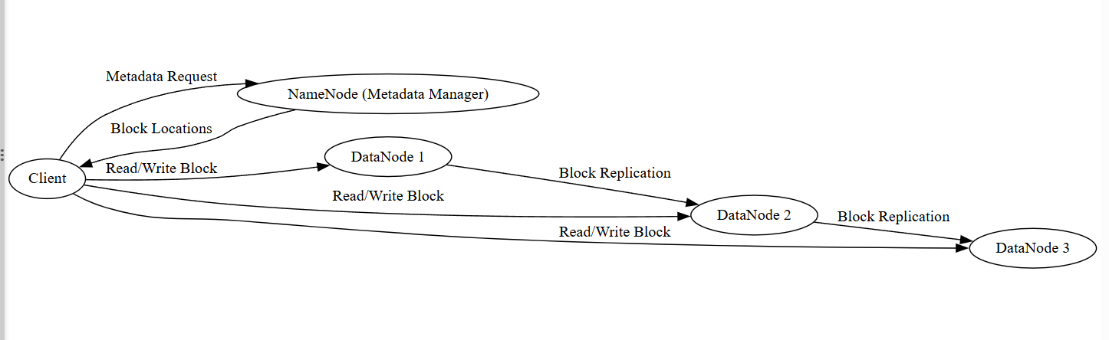─────────────────────────────────────────────────────────────────
Key Features of HDFS
- High fault tolerance through replication
- Designed for large files
- Scalable storage across many machines
- High throughput data access
- Automatic failure recovery
─────────────────────────────────────────────────────────────────
Advantages
- Handles petabyte-scale data
- Low-cost hardware usage
- Reliable data storage
- Supports parallel data processing
─────────────────────────────────────────────────────────────────
Limitations
- Not suitable for small files
- High latency access
- Single NameNode can become bottleneck
- Limited random write support
─────────────────────────────────────────────────────────────────
HDFS is a robust distributed storage system optimized for large-scale data-intensive applications requiring reliability, scalability, and high throughput.
─────────────────────────────────────────────────────────────────
Google File System (GFS)
Google File System (GFS) is a scalable distributed file system developed by Google to support large-scale data processing applications such as search indexing, data mining, and machine learning. It is designed to run on clusters of commodity hardware and handle frequent component failures while providing high performance.
GFS focuses on high throughput, fault tolerance, and efficient handling of massive datasets.
─────────────────────────────────────────────────────────────────
Architecture of GFS
GFS follows a master–chunk server architecture consisting of:
- GFS Master
- Chunk Servers
- Clients
─────────────────────────────────────────────────────────────────
GFS Master
The master node manages metadata such as:
- File namespace and directory structure
- Chunk locations
- Access control
- Load balancing
- Garbage collection
It maintains metadata in memory for fast access.
─────────────────────────────────────────────────────────────────
Chunk Servers
Chunk servers store actual data in large fixed-size chunks (typically 64 MB).
They:
- Read and write chunk data
- Replicate chunks across servers
- Report status to the master
- Handle failure recovery
─────────────────────────────────────────────────────────────────
Clients
Clients communicate with the master to obtain metadata and then directly interact with chunk servers for data transfer.
─────────────────────────────────────────────────────────────────
Data Storage Mechanism
Files are divided into large chunks.
Each chunk is replicated on multiple chunk servers for fault tolerance.
The master keeps track of chunk locations and system health.
─────────────────────────────────────────────────────────────────
Diagram required here — Google File System Architecture
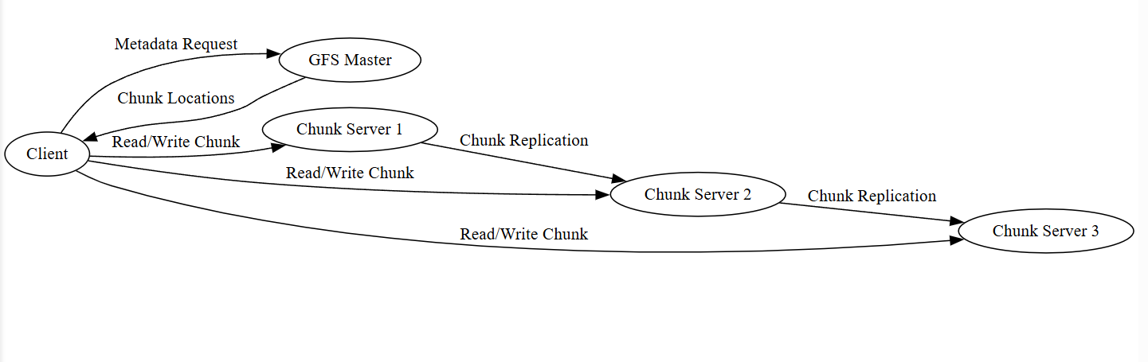─────────────────────────────────────────────────────────────────
Key Features of GFS
- Large chunk size for high throughput
- Automatic replication and recovery
- Centralized metadata management
- Designed for frequent failures
- Optimized for batch processing
─────────────────────────────────────────────────────────────────
Advantages
- Highly scalable
- Efficient large file handling
- Strong fault tolerance
- High performance for big data workloads
─────────────────────────────────────────────────────────────────
Limitations
- Central master may become bottleneck
- Not suitable for low-latency applications
- Limited support for small files
─────────────────────────────────────────────────────────────────
Google File System laid the foundation for modern distributed storage systems and inspired many technologies such as HDFS, making it a cornerstone in large-scale data management.
─────────────────────────────────────────────────────────────────
Difference between Hadoop Distributed File System (HDFS) and Google File System (GFS)
HDFS and GFS are distributed file systems designed to store and manage large-scale data across clusters of commodity hardware. Both follow a master–slave architecture and are optimized for high-throughput data processing. However, they differ in design philosophy, implementation, and usage.
─────────────────────────────────────────────────────────────────
Comparison between HDFS and GFS

Parameter | HDFS | GFS
Developer | Developed by Apache Hadoop community | Developed by Google
Purpose | Open-source distributed storage for big data frameworks | Proprietary distributed file system for Google applications
Architecture | NameNode (master) and DataNodes (slaves) | GFS Master and Chunk Servers
Block/Chunk Size | Typically 128 MB (or configurable) | Typically 64 MB
Metadata Storage | Stored by NameNode in memory and disk | Stored by Master in memory
Availability | Open-source and widely used in industry | Internal to Google (not publicly available)
Integration | Works with Hadoop ecosystem (MapReduce, Spark) | Designed for Google’s internal systems
Fault Tolerance | Data replication (default replication factor 3) | Data replication with automatic recovery
Write Model | Single writer, multiple readers | Supports record append operations efficiently
Scalability | Highly scalable across commodity hardware | Highly scalable within Google infrastructure

─────────────────────────────────────────────────────────────────
Architectural Difference
Diagram required here — Architectural Comparison
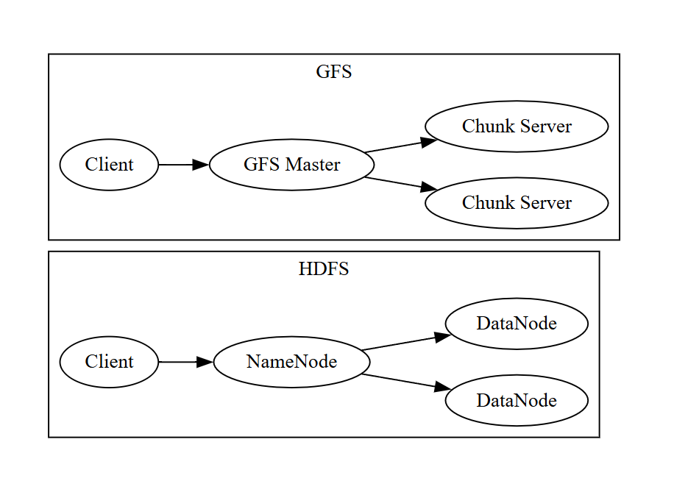─────────────────────────────────────────────────────────────────
Key Differences Explained
HDFS is an open-source implementation inspired by GFS and is widely adopted in big data processing frameworks. It typically uses larger block sizes (128 MB) compared to GFS (64 MB).
GFS is optimized for Google’s internal workloads and emphasizes efficient record append operations. HDFS is tightly integrated with Hadoop and other open-source big data tools.
While both systems provide high fault tolerance through replication and are designed for large-scale batch processing, GFS remains proprietary, whereas HDFS is widely available and customizable.
─────────────────────────────────────────────────────────────────
HDFS and GFS share similar architectural concepts, but differ in implementation details, ecosystem integration, and deployment environments.
─────────────────────────────────────────────────────────────────
Cluster Computing
Cluster computing is a type of distributed computing in which multiple independent computers (called nodes) are connected through a high-speed network and work together as a single unified system to perform computational tasks. Each node in the cluster contributes its processing power, memory, and storage to solve large and complex problems efficiently.
The main objective of cluster computing is to achieve high performance, scalability, and reliability at lower cost by using commodity hardware.
─────────────────────────────────────────────────────────────────
Basic Concept of Cluster Computing
In a cluster system, tasks are divided into smaller subtasks and distributed among multiple nodes. These nodes execute the tasks in parallel and return the results to a central coordinator (master node), which combines the outputs to produce the final result.
To users and applications, the cluster appears as one powerful computer.
─────────────────────────────────────────────────────────────────
Components of a Cluster Computing System
1. Master Node
The master node controls the cluster by:
- Scheduling tasks
- Distributing workload
- Monitoring node health
- Managing resources
─────────────────────────────────────────────────────────────────
2. Worker Nodes
Worker nodes perform actual computation. They:
- Execute assigned tasks
- Process data in parallel
- Send results back to the master node
─────────────────────────────────────────────────────────────────
3. High-Speed Network
Nodes are connected through fast communication links to reduce latency and improve data transfer speed.
─────────────────────────────────────────────────────────────────
Diagram required here — Cluster Computing Architecture
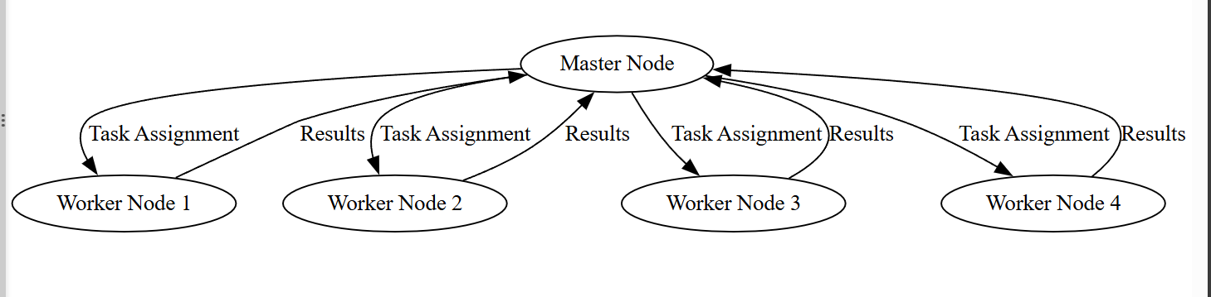─────────────────────────────────────────────────────────────────
Types of Cluster Computing
1. High Performance Clusters (HPC)
Used for scientific simulations, weather forecasting, and AI model training.
2. Load Balancing Clusters
Distribute network traffic across servers to improve performance.
3. High Availability Clusters
Ensure continuous service by providing failover support.
─────────────────────────────────────────────────────────────────
Advantages of Cluster Computing
- High computational speed through parallel processing
- Scalability by adding more nodes
- Cost-effective using commodity hardware
- Improved reliability and fault tolerance
- Efficient resource utilization
─────────────────────────────────────────────────────────────────
Limitations
- Complex system management
- Network dependency
- Communication overhead
- Synchronization challenges
─────────────────────────────────────────────────────────────────
Cluster computing is a powerful distributed computing approach that enables high-performance processing, scalability, and reliability, forming the foundation of modern cloud platforms, big data systems, and AI workloads.
─────────────────────────────────────────────────────────────────
Amazon Web Services (AWS)
Amazon Web Services (AWS) is a cloud computing platform provided by Amazon that delivers on-demand computing resources over the internet. It provides scalable infrastructure, storage, networking, databases, and AI services using a distributed data center architecture.
AWS follows a pay-as-you-go model, allowing organizations to use computing resources without maintaining physical infrastructure.
─────────────────────────────────────────────────────────────────
Architecture of AWS
AWS operates through globally distributed data centers organized into:
- Regions
- Availability Zones
- Edge Locations
Regions
A region is a geographical area containing multiple isolated data centers.
Availability Zones
Each region contains multiple availability zones. These are physically separate data centers designed for fault tolerance and high availability.
Edge Locations
Used for content delivery and low-latency services.
─────────────────────────────────────────────────────────────────
Diagram required here — AWS Global Architecture
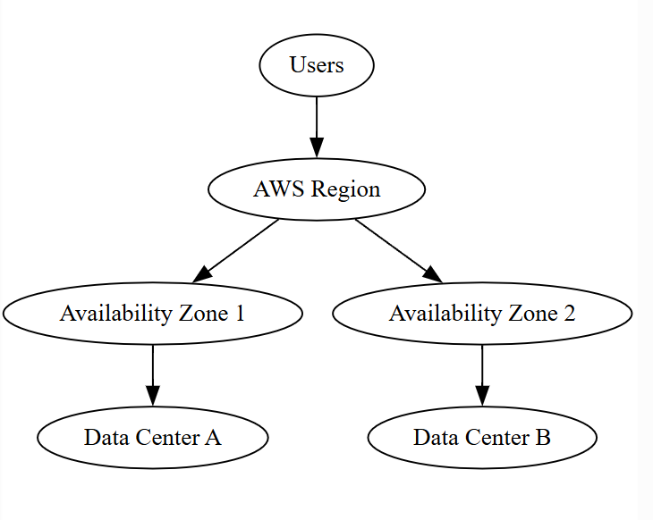─────────────────────────────────────────────────────────────────
Core AWS Services
1. Compute Services
- EC2 (Elastic Compute Cloud) – Virtual machines
- Lambda – Serverless computing
- ECS/EKS – Container services
─────────────────────────────────────────────────────────────────
2. Storage Services
- S3 (Simple Storage Service) – Object storage
- EBS – Block storage
- Glacier – Archival storage
─────────────────────────────────────────────────────────────────
3. Database Services
- RDS – Relational database
- DynamoDB – NoSQL database
- Redshift – Data warehouse
─────────────────────────────────────────────────────────────────
4. Networking Services
- VPC – Virtual private cloud
- CloudFront – Content delivery network
- Route 53 – DNS service
─────────────────────────────────────────────────────────────────
5. AI and Analytics Services
- SageMaker – Machine learning platform
- EMR – Big data processing
- Kinesis – Real-time data streaming
─────────────────────────────────────────────────────────────────
Features of AWS
- Elastic scalability
- High availability
- Global infrastructure
- Strong security mechanisms
- Cost-effective pay-per-use model
─────────────────────────────────────────────────────────────────
Advantages
- No need for physical hardware
- Rapid deployment of applications
- Highly scalable infrastructure
- Reliable and fault-tolerant
- Wide range of services
─────────────────────────────────────────────────────────────────
Limitations
- Ongoing operational cost
- Internet dependency
- Vendor lock-in risk
- Complex service management
─────────────────────────────────────────────────────────────────
AWS is a leading cloud computing platform that provides scalable, distributed infrastructure and services for modern applications including big data, AI, web hosting, and enterprise systems.
─────────────────────────────────────────────────────────────────
Microsoft Azure
Microsoft Azure is a cloud computing platform and distributed computing environment provided by Microsoft that delivers on-demand computing resources such as virtual machines, storage, databases, networking, analytics, and AI services over the internet.
Azure uses a globally distributed data center infrastructure that allows applications to run reliably, securely, and at massive scale.
─────────────────────────────────────────────────────────────────
Architecture of Microsoft Azure
Azure operates through a hierarchical distributed structure:
Regions
A region is a geographical area containing multiple Microsoft data centers.
Availability Zones
Each region consists of separate availability zones designed for:
- Fault isolation
- High availability
- Disaster recovery
Data Centers
Each availability zone contains one or more large-scale data centers equipped with computing, storage, and networking hardware.
─────────────────────────────────────────────────────────────────
Diagram required here — Azure Cloud Infrastructure
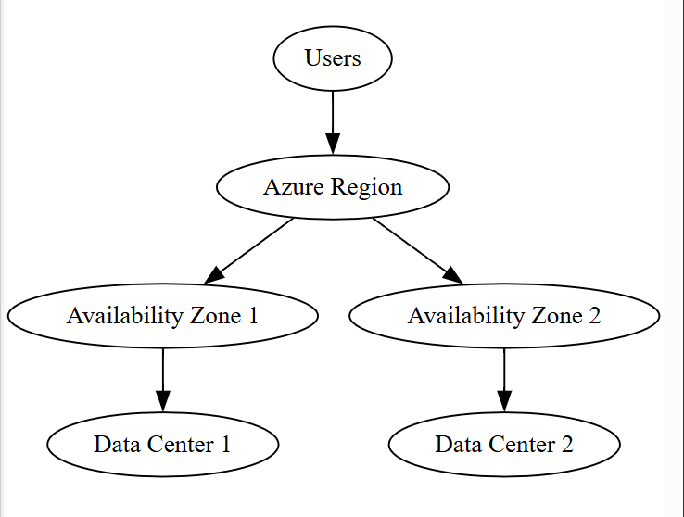─────────────────────────────────────────────────────────────────
Core Microsoft Azure Services
1. Compute Services
- Azure Virtual Machines
- Azure App Services
- Azure Functions (serverless computing)
- Azure Kubernetes Service (AKS)
─────────────────────────────────────────────────────────────────
2. Storage Services
- Azure Blob Storage
- Azure Disk Storage
- Azure File Storage
- Azure Archive Storage
─────────────────────────────────────────────────────────────────
3. Database Services
- Azure SQL Database
- Cosmos DB (NoSQL)
- MySQL and PostgreSQL services
─────────────────────────────────────────────────────────────────
4. Networking Services
- Azure Virtual Network (VNet)
- Azure Load Balancer
- Azure CDN
- Azure DNS
─────────────────────────────────────────────────────────────────
5. AI and Analytics Services
- Azure Machine Learning
- Azure Synapse Analytics
- Azure Data Factory
- Azure Stream Analytics
─────────────────────────────────────────────────────────────────
Key Features of Azure
- Global distributed infrastructure
- High availability and disaster recovery
- Elastic scalability
- Strong security and compliance
- Integration with Microsoft ecosystem
─────────────────────────────────────────────────────────────────
Advantages
- Seamless integration with Windows and Microsoft tools
- Scalable distributed architecture
- Enterprise-grade security
- Wide range of cloud services
- Reliable global performance
─────────────────────────────────────────────────────────────────
Limitations
- Complex pricing structure
- Requires cloud expertise for optimization
- Internet dependency
- Potential vendor lock-in
─────────────────────────────────────────────────────────────────
Microsoft Azure is a powerful distributed cloud platform that supports large-scale computing, storage, analytics, and AI workloads with high reliability and scalability across global data centers.
─────────────────────────────────────────────────────────────────
Google Cloud Platform (GCP)
Google Cloud Platform (GCP) is a cloud computing platform provided by Google that delivers distributed computing services such as virtual machines, storage, databases, networking, big data processing, and artificial intelligence over the internet. It runs on the same global infrastructure that supports Google’s core services like Search, Gmail, and YouTube.
GCP provides scalable, reliable, and high-performance cloud resources using a distributed data center architecture.
─────────────────────────────────────────────────────────────────
Architecture of Google Cloud Platform
GCP infrastructure is organized into:
1. Regions
A region is a specific geographic location containing multiple data centers.
2. Zones
Each region contains multiple independent zones designed for fault tolerance and high availability.
3. Global Network
Google’s private high-speed network connects all regions and zones, ensuring low latency and secure communication.
─────────────────────────────────────────────────────────────────
Diagram required here — GCP Distributed Infrastructure
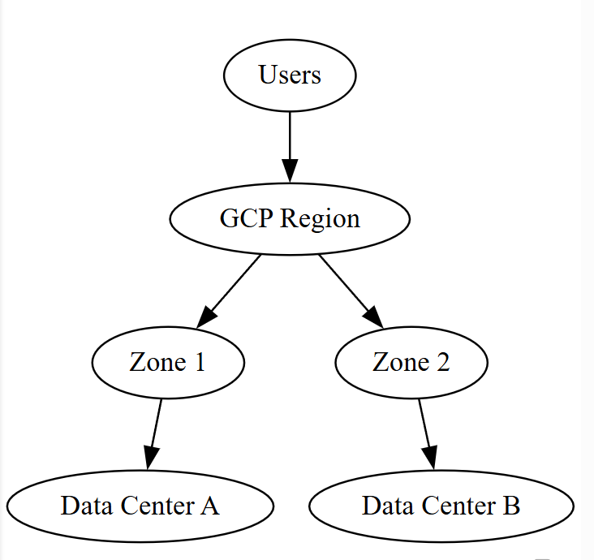
─────────────────────────────────────────────────────────────────
Core GCP Services
1. Compute Services
- Compute Engine – Virtual machines
- Google Kubernetes Engine (GKE) – Container orchestration
- Cloud Functions – Serverless computing
- App Engine – Platform-as-a-Service
─────────────────────────────────────────────────────────────────
2. Storage Services
- Cloud Storage – Object storage
- Persistent Disk – Block storage
- Cloud Filestore – File storage
- Archive storage solutions
─────────────────────────────────────────────────────────────────
3. Database Services
- Cloud SQL – Managed relational databases
- Firestore – NoSQL database
- Bigtable – Large-scale distributed database
- Spanner – Globally distributed relational database
─────────────────────────────────────────────────────────────────
4. Big Data and Analytics
- BigQuery – Data warehouse
- Dataflow – Stream and batch processing
- Dataproc – Managed Hadoop and Spark
- Pub/Sub – Messaging service
─────────────────────────────────────────────────────────────────
5. AI and Machine Learning
- Vertex AI – Machine learning platform
- AutoML – Automated model training
- Vision API, Speech-to-Text API, NLP API
─────────────────────────────────────────────────────────────────
Key Features of GCP
- High-performance global private network
- Strong integration with data analytics tools
- Elastic scalability
- High availability and fault tolerance
- Advanced AI and ML capabilities
─────────────────────────────────────────────────────────────────
Advantages
- Excellent support for big data analytics
- Fast networking infrastructure
- Scalable and flexible resource management
- Strong container and Kubernetes support
─────────────────────────────────────────────────────────────────
Limitations
- Pricing complexity
- Learning curve for advanced services
- Internet dependency
- Vendor lock-in concerns
─────────────────────────────────────────────────────────────────
Google Cloud Platform is a powerful distributed cloud computing environment that provides scalable infrastructure, advanced analytics, and AI capabilities, making it suitable for large-scale enterprise and data-intensive applications.
─────────────────────────────────────────────────────────────────
Difference between AWS, Microsoft Azure, and Google Cloud Platform (GCP)
Cloud platforms provide distributed computing resources over the internet, but they differ in architecture focus, service maturity, ecosystem integration, and strengths.
Below is a detailed engineering-level comparison.
(Platforms compared: , , )
─────────────────────────────────────────────────────────────────
Core Difference Table

Parameter | AWS | Microsoft Azure | GCP
Provider | Amazon | Microsoft | Google
Market Position | Oldest & largest cloud provider | Strong enterprise/cloud hybrid | Strong in data & AI workloads
Infrastructure Style | Highly distributed regions & AZs | Deep enterprise-integrated cloud | High-speed global private network
Strength Area | General-purpose cloud + scalability | Enterprise apps + hybrid cloud | Big data, analytics, ML

─────────────────────────────────────────────────────────────────
Architecture Comparison
AWS
• Region → Availability Zones → Data Centers
• Strong isolation between zones
• Massive global coverage
Azure
• Region → Availability Zones → Data Centers
• Deep integration with Microsoft enterprise systems
• Hybrid cloud support
GCP
• Region → Zones + Google private global network
• Faster inter-region data transfer
• Optimized for large-scale data processing
─────────────────────────────────────────────────────────────────
Service Strength Comparison

Area | AWS | Azure | GCP
Compute | EC2, Lambda | Virtual Machines, Functions | Compute Engine, Cloud Functions
Storage | S3, EBS | Blob, Disk Storage | Cloud Storage
Databases | RDS, DynamoDB | Azure SQL, Cosmos DB | Bigtable, Spanner
Big Data | EMR | Synapse | BigQuery
AI/ML | SageMaker | Azure ML | Vertex AI
Containers | ECS, EKS | AKS | GKE (best in industry)

─────────────────────────────────────────────────────────────────
Scalability & Performance
AWS
✔ Extremely scalable
✔ Handles massive workloads reliably
✔ Very mature infrastructure
Azure
✔ Excellent for enterprise scaling
✔ Best for Microsoft-based systems
GCP
✔ Extremely fast data processing
✔ Best for large analytics & ML workloads
─────────────────────────────────────────────────────────────────
Security & Compliance

Feature | AWS | Azure | GCP
Encryption | Yes | Yes | Yes
Identity Control | IAM | Azure Active Directory | Cloud IAM
Compliance | Very high | Very high (enterprise focus) | High

All three provide strong enterprise-grade security.
─────────────────────────────────────────────────────────────────
Cost Model Comparison

Factor | AWS | Azure | GCP
Pricing | Pay-as-you-go (complex) | Pay-as-you-go | Often cheaper for data workloads
Discounts | Reserved instances | Hybrid benefits | Sustained-use discounts
Cost Transparency | Medium | Medium | High

─────────────────────────────────────────────────────────────────
Use-Case Suitability
AWS Best For:
• Large scalable web apps
• Startups to enterprises
• General cloud computing
• Distributed systems at massive scale
Azure Best For:
• Enterprises using Windows/Office
• Hybrid cloud solutions
• Corporate IT systems
GCP Best For:
• Big data analytics
• AI/ML pipelines
• High-speed distributed processing
─────────────────────────────────────────────────────────────────
Advantages Summary
AWS
✔ Most services available
✔ Most mature platform
✔ Huge global reach
✔ Strong community support
Azure
✔ Best enterprise integration
✔ Hybrid cloud leader
✔ Strong security ecosystem
GCP
✔ Best data analytics tools
✔ Fastest network
✔ Excellent AI infrastructure
─────────────────────────────────────────────────────────────────
Limitations Summary
AWS
❌ Complex pricing
❌ Management complexity
Azure
❌ Slightly less mature in some services
❌ Pricing can be confusing
GCP
❌ Smaller service ecosystem
❌ Less enterprise market share
─────────────────────────────────────────────────────────────────
Final Engineering Conclusion (Important for Exams)
AWS is the most comprehensive and scalable cloud platform.
Azure excels in enterprise and hybrid cloud environments.
GCP leads in data analytics, AI, and high-speed distributed processing.
All three are distributed computing platforms but optimized for different real-world workloads.
─────────────────────────────────────────────────────────────────
Message Brokers & Stream Processing in Distributed Systems
Message brokers and stream processing systems are core technologies used in distributed computing to enable reliable communication, real-time data flow, and scalable event-driven processing across multiple distributed components.
They decouple data producers from data consumers and allow systems to process continuous streams of information efficiently.
─────────────────────────────────────────────────────────────────
Message Brokers
A message broker is an intermediary software system that receives messages from producers, stores them temporarily, and forwards them to consumers.
It enables asynchronous communication between distributed components.
─────────────────────────────────────────────────────────────────
Working of a Message Broker
- 1. Producers send messages to the broker
- 2. The broker queues or routes messages
- 3. Consumers retrieve messages when ready
- 4. Messages are acknowledged after processing
This ensures reliable delivery even if some components are temporarily offline.
─────────────────────────────────────────────────────────────────
Key Functions of Message Brokers
- Message queuing
- Routing and filtering
- Load balancing
- Fault tolerance
- Guaranteed delivery
- Decoupling of system components
─────────────────────────────────────────────────────────────────
Benefits of Message Brokers
- Improved system reliability
- Loose coupling between services
- Scalability
- Asynchronous processing
- Better fault handling
─────────────────────────────────────────────────────────────────
Diagram required here — Message Broker Architecture
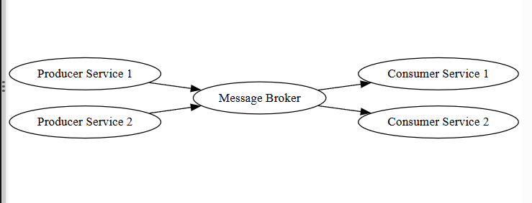─────────────────────────────────────────────────────────────────
Stream Processing
Stream processing is a computing technique used to process continuous flows of real-time data as they are generated, rather than storing data first and processing later in batches.
It is essential for applications requiring immediate insights and rapid responses.
─────────────────────────────────────────────────────────────────
Working of Stream Processing
- 1. Data is continuously generated from sources such as sensors, applications, or transactions
- 2. Data streams enter distributed processing nodes
- 3. Real-time analytics and transformations are applied
- 4. Results are produced instantly for monitoring or decision-making
─────────────────────────────────────────────────────────────────
Characteristics of Stream Processing
- Real-time data handling
- Continuous computation
- Low latency
- High throughput
- Fault-tolerant processing
─────────────────────────────────────────────────────────────────
Applications of Stream Processing
- Fraud detection
- Stock market analysis
- IoT sensor monitoring
- Real-time recommendation systems
- Log analytics
- Traffic management
─────────────────────────────────────────────────────────────────
Diagram required here — Stream Processing Flow
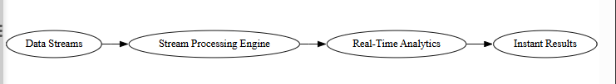─────────────────────────────────────────────────────────────────
Integration of Message Brokers and Stream Processing
In modern distributed systems:
- Message brokers handle reliable data ingestion
- Stream processors analyze data in real time
Together they form scalable real-time data pipelines.
─────────────────────────────────────────────────────────────────
Advantages
- High system scalability
- Real-time data insights
- Improved reliability
- Efficient distributed communication
- Event-driven system design
─────────────────────────────────────────────────────────────────
Challenges
- Handling high data velocity
- Ensuring fault tolerance
- Managing message ordering
- Latency control
- Infrastructure complexity
─────────────────────────────────────────────────────────────────
Message brokers and stream processing systems are essential building blocks of modern distributed architectures, enabling reliable communication and real-time analytics across large-scale distributed environments.
─────────────────────────────────────────────────────────────────
Edge Computing
Edge computing is a distributed computing paradigm in which data processing and computation are performed closer to the data source (edge of the network) rather than relying entirely on centralized cloud data centers. This approach reduces latency, saves bandwidth, and enables real-time decision-making.
Edge computing is especially important for applications that generate large volumes of data and require immediate responses.
─────────────────────────────────────────────────────────────────
Concept of Edge Computing
In traditional cloud computing, data generated by devices is transmitted to centralized servers for processing. In edge computing, computation is pushed closer to where data is generated, such as sensors, gateways, or local servers.
Only necessary or summarized data is sent to the cloud for long-term storage or advanced analytics.
─────────────────────────────────────────────────────────────────
Need for Edge Computing
Edge computing is required due to:
- High latency in cloud-based processing
- Massive data generation by IoT devices
- Limited network bandwidth
- Need for real-time processing
- Reliability issues due to network failures
─────────────────────────────────────────────────────────────────
Architecture of Edge Computing
Edge computing architecture typically consists of three layers:
- 1. Edge Devices – Sensors, cameras, smart devices
- 2. Edge Nodes/Gateways – Local processing units
- 3. Cloud/Data Center – Centralized storage and analytics
─────────────────────────────────────────────────────────────────
Diagram required here — Edge Computing Architecture
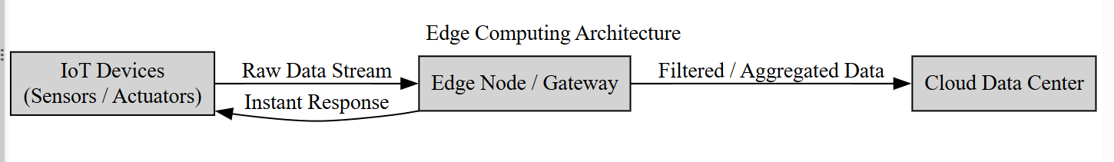─────────────────────────────────────────────────────────────────
Working Mechanism
- 1. Data is generated by edge devices such as sensors or cameras.
- 2. Edge nodes perform local processing, filtering, and analytics.
- 3. Immediate decisions are made at the edge for real-time actions.
- 4. Processed or summarized data is sent to the cloud for storage and further analysis.
─────────────────────────────────────────────────────────────────
Applications of Edge Computing
- Internet of Things (IoT) systems
- Autonomous vehicles
- Smart cities
- Industrial automation
- Healthcare monitoring
- Video surveillance
- Augmented and virtual reality
─────────────────────────────────────────────────────────────────
Advantages of Edge Computing
- Reduced latency
- Faster response time
- Lower bandwidth usage
- Improved reliability
- Enhanced data privacy
- Real-time analytics
─────────────────────────────────────────────────────────────────
Challenges of Edge Computing
- Limited computing resources at edge nodes
- Security management across distributed edges
- Device management complexity
- Data synchronization issues
- Scalability challenges
─────────────────────────────────────────────────────────────────
Edge computing complements cloud computing by enabling low-latency, real-time processing at the network edge, making it a critical technology for modern distributed and IoT-based systems.
─────────────────────────────────────────────────────────────────
Data Replication & Consistency Models
In distributed systems, data is stored across multiple nodes to ensure availability, fault tolerance, and scalability. To achieve reliability, data is replicated across different machines. However, replication introduces the challenge of maintaining consistency among multiple copies.
Data replication defines how copies of data are maintained, while consistency models define how updates are visible to users across replicas.
─────────────────────────────────────────────────────────────────
Part I — Data Replication
Data replication is the process of storing copies of data on multiple nodes in a distributed system to improve availability, reliability, and fault tolerance.
─────────────────────────────────────────────────────────────────
1. Eager Replication (Synchronous Replication)
In eager replication, updates are applied to all replicas simultaneously before the operation is considered complete.
When a client updates data:
- 1. The update is sent to all replica nodes.
- 2. Each replica confirms the update.
- 3. Only after confirmation is the transaction committed.
Characteristics:
- Strong consistency
- High reliability
- Higher latency
- Increased communication overhead
─────────────────────────────────────────────────────────────────
2. Lazy Replication (Asynchronous Replication)
In lazy replication, updates are applied to one primary replica first, and changes are propagated to other replicas later.
When a client updates data:
- 1. Primary node updates immediately.
- 2. Other replicas are updated asynchronously.
Characteristics:
- Faster response time
- Lower immediate communication cost
- Temporary inconsistency possible
─────────────────────────────────────────────────────────────────
3. Quorum-Based Replication
In quorum-based replication, a subset of replicas must agree on read or write operations.
Parameters:
- N = total number of replicas
- W = minimum replicas required for write
- R = minimum replicas required for read
Consistency condition:
R + W > N
This ensures overlap between read and write operations.
─────────────────────────────────────────────────────────────────
4. Consensus-Based Replication
Consensus-based replication ensures that all nodes agree on the same sequence of updates before committing changes.
It uses agreement protocols to maintain consistency even during failures.
Characteristics:
- Strong consistency
- High fault tolerance
- Higher complexity
- Suitable for critical systems
─────────────────────────────────────────────────────────────────
5. Selective Replication
Selective replication stores copies of only frequently accessed or critical data on multiple nodes.
It reduces storage overhead while maintaining availability for important data.
─────────────────────────────────────────────────────────────────
Diagram required here — Data Replication Model
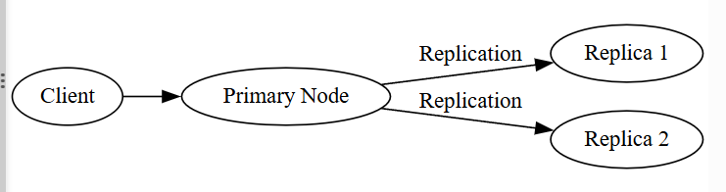─────────────────────────────────────────────────────────────────
Part II — Consistency Models
Consistency models define the rules that determine how and when updates made to data are visible to users.
─────────────────────────────────────────────────────────────────
1. Strong Consistency
After an update, all subsequent reads return the most recent value.
Characteristics:
- Immediate consistency
- High reliability
- Increased latency
─────────────────────────────────────────────────────────────────
2. Eventual Consistency
If no new updates occur, all replicas will eventually converge to the same value.
Characteristics:
- High availability
- Better performance
- Temporary inconsistencies allowed
─────────────────────────────────────────────────────────────────
3. Read-Your-Writes Consistency
A user always sees their own updates immediately after writing.
Useful in user-centric applications.
─────────────────────────────────────────────────────────────────
4. Consistent Prefix Consistency
Updates are seen in the same order by all nodes. If a process sees update A, it must also see all updates before A.
─────────────────────────────────────────────────────────────────
5. Causal Consistency
Operations that are causally related must be seen in the same order by all nodes. Independent operations may appear in different orders.
─────────────────────────────────────────────────────────────────
Trade-off: CAP Principle
In distributed systems, it is impossible to simultaneously guarantee:
- Consistency
- Availability
- Partition tolerance
Systems must balance these properties depending on requirements.
─────────────────────────────────────────────────────────────────
Data replication improves reliability and availability, while consistency models control how updates propagate across replicas. Together, they ensure correct and scalable data management in distributed systems.
─────────────────────────────────────────────────────────────────
Eager Replication (Synchronous Replication)
Eager replication is a data replication technique in distributed systems in which every update made to a data item is immediately propagated to all its replicas before the transaction is considered complete. The system ensures that all copies of data remain consistent at all times.
This method emphasizes strong consistency and reliability by keeping all replicas synchronized.
─────────────────────────────────────────────────────────────────
Working Mechanism of Eager Replication
When a client performs an update:
- 1. The update request is sent to the primary node or coordinator
- 2. The coordinator forwards the update to all replica nodes
- 3. Each replica applies the update and sends acknowledgment
- 4. Only after all acknowledgments are received is the update committed
If any replica fails to update, the transaction is rolled back or delayed.
─────────────────────────────────────────────────────────────────
Diagram required here — Eager Replication Process
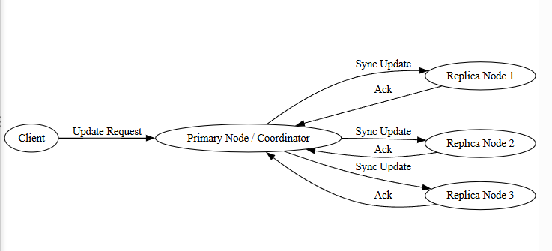─────────────────────────────────────────────────────────────────
Characteristics of Eager Replication
- Updates applied simultaneously to all replicas
- Strong consistency maintained
- High data reliability
- Immediate synchronization
- Requires acknowledgment from all nodes
─────────────────────────────────────────────────────────────────
Advantages
- No stale or outdated data
- Strong data consistency
- High reliability
- Suitable for critical applications
─────────────────────────────────────────────────────────────────
Limitations
- High communication overhead
- Increased response time
- Poor scalability for large systems
- Sensitive to network failures
─────────────────────────────────────────────────────────────────
Applications
- Banking systems
- Financial transactions
- Airline reservation systems
- Inventory control systems
- Distributed databases requiring strict consistency
─────────────────────────────────────────────────────────────────
Eager replication is best suited for systems where data correctness is more important than performance, ensuring that all users always see the most up-to-date and consistent information across distributed nodes.
─────────────────────────────────────────────────────────────────
Lazy Replication (Asynchronous Replication)
Lazy replication is a data replication strategy in distributed systems in which updates are first applied to one primary replica and then propagated to other replicas at a later time. Unlike eager replication, the system does not wait for all replicas to acknowledge the update before completing the operation.
This approach prioritizes performance and availability over immediate consistency.
─────────────────────────────────────────────────────────────────
Working Mechanism of Lazy Replication
When a client performs an update:
- 1. The update is sent to the primary node.
- 2. The primary node updates its local copy and immediately confirms the operation to the client.
- 3. The update is later propagated asynchronously to secondary replicas.
- 4. Secondary replicas update their copies when they receive the update message.
Because propagation is delayed, temporary inconsistency may occur.
─────────────────────────────────────────────────────────────────
Diagram required here — Lazy Replication Process
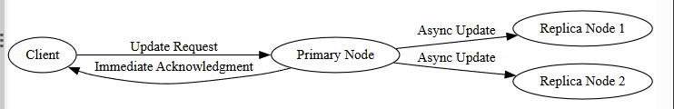─────────────────────────────────────────────────────────────────
Characteristics of Lazy Replication
- Updates first applied to primary replica
- Replicas updated asynchronously
- Temporary inconsistency possible
- Lower immediate communication overhead
- Faster response time
─────────────────────────────────────────────────────────────────
Advantages
- Improved system performance
- Reduced latency
- Better scalability
- Higher availability during network delays
─────────────────────────────────────────────────────────────────
Limitations
- Data may become temporarily inconsistent
- Risk of stale reads
- Conflict resolution required if multiple updates occur
- Not suitable for critical real-time systems
─────────────────────────────────────────────────────────────────
Applications
- Social media platforms
- E-commerce recommendation systems
- Content delivery networks
- Large-scale web applications
─────────────────────────────────────────────────────────────────
Lazy replication is suitable for distributed systems where high availability and performance are more important than immediate consistency, allowing the system to scale efficiently while tolerating temporary inconsistencies.
─────────────────────────────────────────────────────────────────
Quorum-Based Replication
Quorum-based replication is a data replication technique used in distributed systems to maintain consistency and fault tolerance by requiring a minimum number of replica nodes (called a quorum) to participate in read and write operations.
Instead of updating or reading from all replicas, the system communicates with a selected subset of nodes to ensure correctness while improving performance and availability.
─────────────────────────────────────────────────────────────────
Basic Concept
In a distributed system:
- Data is replicated across N nodes
- For every write operation, at least W replicas must confirm the update
- For every read operation, at least R replicas must respond
To guarantee consistency, the following condition must be satisfied:
R + W > N
This ensures that at least one replica involved in a write is also included in every read, preventing stale data.
─────────────────────────────────────────────────────────────────
Working Mechanism
Write Operation:
- 1. Client sends update request
- 2. System writes data to W replica nodes
- 3. Once W acknowledgments are received, write is considered successful
Read Operation:
- 1. Client requests data
- 2. System reads data from R replica nodes
- 3. Latest version is selected and returned
─────────────────────────────────────────────────────────────────
Diagram required here — Quorum Replication Process
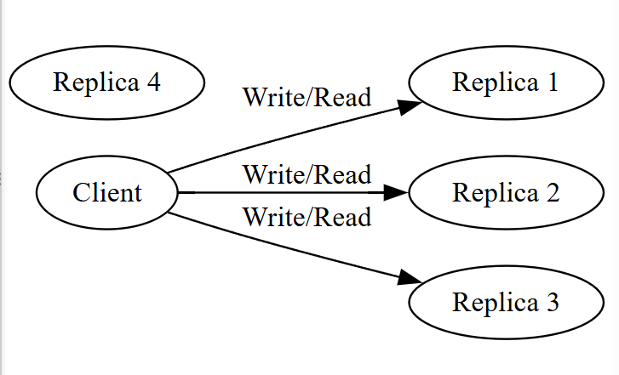─────────────────────────────────────────────────────────────────
Characteristics
- Partial replica participation
- Balance between consistency and performance
- Fault tolerant
- Adjustable quorum sizes
─────────────────────────────────────────────────────────────────
Advantages
- Stronger consistency than lazy replication
- Lower overhead than eager replication
- High availability
- Flexible tuning of performance vs consistency
─────────────────────────────────────────────────────────────────
Limitations
- Increased complexity
- Network communication overhead
- Requires version control
- Still possible delays during failures
─────────────────────────────────────────────────────────────────
Applications
- Distributed databases
- Cloud storage systems
- NoSQL data stores
- Large-scale distributed services
─────────────────────────────────────────────────────────────────
Quorum-based replication offers a practical trade-off between strong consistency and high performance by ensuring overlapping read and write sets, making it widely used in scalable distributed systems.
─────────────────────────────────────────────────────────────────
Consensus-Based Replication
Consensus-based replication is a replication technique in distributed systems where all participating nodes agree on the order and value of updates before they are applied to data replicas. This ensures strong consistency even in the presence of node failures or network partitions.
The goal of consensus is to make sure every non-faulty node maintains the same sequence of updates, keeping all replicas perfectly synchronized.
─────────────────────────────────────────────────────────────────
Basic Concept
In distributed environments:
- Data is replicated across multiple nodes
- Every update must be approved by a majority or all nodes
- Nodes communicate to reach agreement (consensus)
- Only agreed updates are committed
This guarantees correctness and prevents conflicting updates.
─────────────────────────────────────────────────────────────────
Working Mechanism
- 1. A client sends an update request to a coordinator or leader node
- 2. The leader proposes the update to all other replicas
- 3. Replicas verify and vote on the update
- 4. Once a majority agreement is reached, the update is committed
- 5. The update is applied consistently across replicas
If a node fails, the remaining nodes can still reach agreement.
─────────────────────────────────────────────────────────────────
Diagram required here — Consensus Replication Process
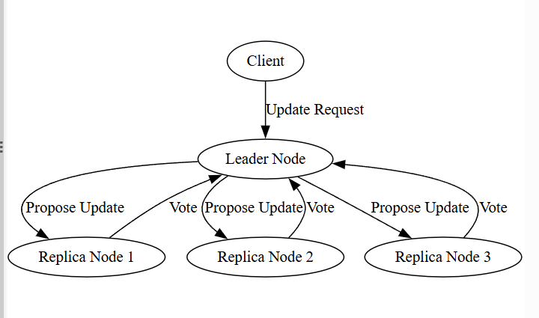─────────────────────────────────────────────────────────────────
Characteristics
- Strong consistency
- Ordered updates across all replicas
- Fault tolerant
- Requires majority agreement
- Handles node failures safely
─────────────────────────────────────────────────────────────────
Advantages
- Guarantees data correctness
- Prevents conflicts
- High reliability
- Suitable for critical systems
─────────────────────────────────────────────────────────────────
Limitations
- High communication overhead
- Increased latency
- Complex protocol design
- Reduced performance for large clusters
─────────────────────────────────────────────────────────────────
Applications
- Distributed databases
- Configuration management systems
- Blockchain platforms
- Financial transaction systems
- Critical infrastructure systems
─────────────────────────────────────────────────────────────────
Consensus-based replication ensures that all replicas remain consistent and synchronized by enforcing agreement before applying updates, making it ideal for systems where data accuracy and reliability are paramount.
─────────────────────────────────────────────────────────────────
Selective Replication
Selective replication is a data replication strategy in distributed systems where only specific data items or frequently accessed data are replicated across multiple nodes, instead of replicating all data everywhere. Less important or rarely used data may be stored in a single location or limited nodes.
The main objective of selective replication is to balance availability, performance, and storage efficiency.
─────────────────────────────────────────────────────────────────
Basic Concept
In large distributed systems, not all data needs the same level of availability.
Selective replication focuses on:
- Replicating critical data
- Replicating frequently accessed data
- Reducing storage overhead for low-priority data
This approach optimizes system resources while still providing fault tolerance for important data.
─────────────────────────────────────────────────────────────────
Working Mechanism
- 1. System analyzes data access patterns and importance
- 2. High-demand or critical data is copied across multiple nodes
- 3. Low-demand data remains on fewer nodes
- 4. Replication policies control where and how many copies exist
Replication decisions may be dynamic based on system usage.
─────────────────────────────────────────────────────────────────
Diagram required here — Selective Replication Model
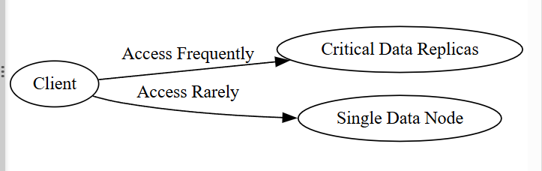─────────────────────────────────────────────────────────────────
Characteristics
- Partial data replication
- Optimized storage usage
- Improved access speed for hot data
- Flexible replication strategy
─────────────────────────────────────────────────────────────────
Advantages
- Reduced storage cost
- Better performance for popular data
- Efficient resource utilization
- Scalable data management
─────────────────────────────────────────────────────────────────
Limitations
- Complex replication management
- Risk of lower availability for non-replicated data
- Requires monitoring of access patterns
- Potential data imbalance
─────────────────────────────────────────────────────────────────
Applications
- Content delivery systems
- Web caching platforms
- Distributed databases
- Cloud storage optimization
- Large-scale data services
─────────────────────────────────────────────────────────────────
Selective replication provides a smart balance between reliability and resource efficiency by replicating only necessary data across distributed nodes based on usage and importance.
─────────────────────────────────────────────────────────────────
Consistency Models in Distributed Systems
Consistency models define the rules that determine how updates made to replicated data are visible to users and processes in a distributed system. Since data is stored across multiple nodes, consistency models control when and in what order changes appear across replicas.
They represent the trade-off between:
✔ Correctness of data
✔ System performance
✔ Availability and scalability
─────────────────────────────────────────────────────────────────
1. Strong Consistency
Strong consistency ensures that once a data update is completed, all subsequent read operations return the latest updated value, regardless of which node is accessed.
All replicas are synchronized immediately.
Characteristics
• No stale data
• Immediate consistency
• High reliability
• Higher latency
• High communication overhead
Example
Bank balance update — every user sees the updated amount instantly.
─────────────────────────────────────────────────────────────────
2. Eventual Consistency
Eventual consistency allows temporary inconsistency between replicas, but guarantees that all replicas will converge to the same value over time if no new updates occur.
Updates propagate asynchronously.
Characteristics
• High availability
• Better performance
• Temporary stale data allowed
• Lower overhead
• Suitable for large-scale systems
Example
Social media post likes updating gradually across servers.
─────────────────────────────────────────────────────────────────
3. Read-Your-Writes Consistency
This model guarantees that a user always sees their own most recent updates.
After writing data, any subsequent read by the same user returns the updated value.
Characteristics
• User-centric consistency
• Prevents confusion for individual users
• Other users may still see old data temporarily
Example
After updating profile details, user sees the change immediately.
─────────────────────────────────────────────────────────────────
4. Consistent Prefix Consistency
In this model, all users see updates in the same order, but may not see the most recent updates immediately.
If a user sees update A, they must also see all updates that occurred before A.
Characteristics
• Preserves update order
• Prevents out-of-order reads
• May lag behind latest data
Example
Log systems where event order matters.
─────────────────────────────────────────────────────────────────
5. Causal Consistency
Causal consistency ensures that causally related updates are seen in the same order by all nodes, while independent updates may appear in different orders.
If operation B depends on operation A, then all nodes must see A before B.
Characteristics
• Maintains cause-effect relationships
• More flexible than strong consistency
• Better performance than strict synchronization
Example
Reply to a message must appear after the original message.
─────────────────────────────────────────────────────────────────
Comparison of Consistency Models

Model | Data Freshness | Performance | Availability
Strong | Immediate | Low | Medium
Eventual | Delayed | High | High
Read-your-writes | Immediate for same user | High | High
Consistent prefix | Ordered | Medium | High
Causal | Cause-effect order | Medium-High | High

─────────────────────────────────────────────────────────────────
Trade-Off Principle
Stronger consistency leads to:
❗ More latency
❗ Higher overhead
Weaker consistency leads to:
✔ Faster systems
✔ Better scalability
Distributed systems choose consistency models based on application needs.
─────────────────────────────────────────────────────────────────
Consistency models are essential for managing replicated data in distributed systems, defining how correctness, performance, and availability are balanced in large-scale environments.
─────────────────────────────────────────────────────────────────
Strong Consistency
Strong consistency is a consistency model in distributed systems where every read operation returns the most recent write immediately. Once a data update is completed, all replicas of that data are synchronized, and no node will return an outdated value.
This model makes a distributed system behave like a single centralized system in terms of data correctness.
─────────────────────────────────────────────────────────────────
Working Principle
When a write operation occurs:
- 1. The update is propagated to all replicas
- 2. All replicas confirm the update
- 3. Only then is the operation considered complete
- 4. Any subsequent read returns the latest value
No replica is allowed to serve stale data.
─────────────────────────────────────────────────────────────────
Characteristics
- Immediate synchronization of replicas
- No data inconsistency
- High reliability and correctness
- Increased communication overhead
- Higher latency
─────────────────────────────────────────────────────────────────
Advantages
- Guaranteed accurate data
- Simplifies application logic
- Ideal for critical systems
- Prevents conflicting updates
─────────────────────────────────────────────────────────────────
Limitations
- Slower performance
- Reduced availability during failures
- High network usage
- Poor scalability for large systems
─────────────────────────────────────────────────────────────────
Typical Applications
- Banking transactions
- Financial systems
- Airline reservations
- Inventory control
- Critical databases
─────────────────────────────────────────────────────────────────
Eventual Consistency
Eventual consistency is a consistency model where replicas are allowed to be temporarily inconsistent, but the system guarantees that all copies will eventually converge to the same value if no further updates occur.
Updates are propagated asynchronously across replicas.
─────────────────────────────────────────────────────────────────
Working Principle
When a write operation occurs:
- 1. The update is applied to one or a few replicas
- 2. The update is propagated gradually to other replicas
- 3. During propagation, some nodes may return old values
- 4. Over time, all replicas become consistent
─────────────────────────────────────────────────────────────────
Characteristics
- Temporary inconsistency allowed
- Asynchronous update propagation
- High availability
- Low latency
- Better scalability
─────────────────────────────────────────────────────────────────
Advantages
- Faster system performance
- High fault tolerance
- Scales efficiently
- Reduced communication overhead
─────────────────────────────────────────────────────────────────
Limitations
- Stale data may be read
- Complex conflict resolution may be needed
- Not suitable for critical systems
─────────────────────────────────────────────────────────────────
Typical Applications
- Social media systems
- Content delivery networks
- E-commerce recommendations
- Distributed caches
- Cloud storage platforms
─────────────────────────────────────────────────────────────────
Strong consistency prioritizes correctness and immediate synchronization, while eventual consistency prioritizes performance, scalability, and availability with temporary relaxation of strict data correctness.
─────────────────────────────────────────────────────────────────
Read-Your-Writes Consistency
Read-your-writes consistency is a consistency model that guarantees a user will always see the results of their own updates immediately. After a process writes a value, any subsequent read by the same process will return the updated value, even if other replicas have not yet received the update.
This model focuses on maintaining correctness from the user’s perspective rather than across all system replicas.
─────────────────────────────────────────────────────────────────
Working Principle
- 1. A user performs a write operation on a data item
- 2. The system ensures that the same user is routed to a replica that has the latest update
- 3. Any read operation by that user returns the updated value
Other users may still see older values temporarily.
─────────────────────────────────────────────────────────────────
Characteristics
- Immediate consistency for the same user
- Temporary inconsistency across different users
- High performance
- High availability
- User-centric consistency
─────────────────────────────────────────────────────────────────
Advantages
- Prevents user confusion
- Maintains smooth user experience
- Faster than strong consistency
- Scales efficiently
─────────────────────────────────────────────────────────────────
Limitations
- Other users may read outdated data
- Requires session management or routing mechanisms
- Not suitable for globally strict correctness
─────────────────────────────────────────────────────────────────
Applications
- User profile updates
- Online forms
- Account settings
- Personal dashboards
─────────────────────────────────────────────────────────────────
Consistent Prefix Consistency
Consistent prefix consistency ensures that all processes see updates in the same sequential order, but may not see the most recent updates immediately.
If a process sees update A, it must also see all updates that happened before A.
─────────────────────────────────────────────────────────────────
Working Principle
Updates are applied in a global sequence. Each replica may lag behind the latest updates, but the order of updates is preserved.
No node will see newer updates without first seeing earlier ones.
─────────────────────────────────────────────────────────────────
Characteristics
- Preserves update order
- Prevents out-of-order reads
- Allows delayed propagation
- High availability
─────────────────────────────────────────────────────────────────
Advantages
- Maintains logical correctness
- Avoids inconsistent event ordering
- Good performance
─────────────────────────────────────────────────────────────────
Limitations
- May not always return latest data
- Requires sequencing mechanisms
- Some synchronization overhead
─────────────────────────────────────────────────────────────────
Applications
- Logging systems
- Event processing systems
- Versioned data stores
─────────────────────────────────────────────────────────────────
Causal Consistency
Causal consistency ensures that operations that are causally related are seen in the same order by all nodes. Independent operations may be seen in different orders.
If operation B depends on operation A, all replicas must observe A before B.
─────────────────────────────────────────────────────────────────
Working Principle
The system tracks cause-effect relationships between operations using timestamps or vector clocks.
Causally related updates are propagated in order.
─────────────────────────────────────────────────────────────────
Characteristics
- Preserves logical causality
- More flexible than strong consistency
- Higher performance than strict synchronization
- Supports concurrent independent updates
─────────────────────────────────────────────────────────────────
Advantages
- Prevents logical inconsistencies
- Improves system responsiveness
- Scales better than strong consistency
─────────────────────────────────────────────────────────────────
Limitations
- More complex implementation
- Some metadata overhead
- Slight propagation delays
─────────────────────────────────────────────────────────────────
Applications
- Messaging systems
- Collaborative applications
- Social networks
- Distributed version control
─────────────────────────────────────────────────────────────────
Read-your-writes consistency ensures user-level correctness, consistent prefix preserves update order, and causal consistency maintains cause-effect relationships — together forming practical consistency models for scalable distributed systems.
─────────────────────────────────────────────────────────────────
Distributed Data Indexing & Retrieval Techniques
In distributed systems, data is stored across multiple nodes, making efficient search and retrieval a major challenge. Distributed data indexing techniques organize data in structured ways that allow fast location and access of information without scanning the entire distributed storage.
These techniques improve system performance, scalability, and response time in large-scale distributed databases and storage systems.
─────────────────────────────────────────────────────────────────
Need for Distributed Indexing
Distributed indexing is required to:
- Quickly locate data across multiple machines
- Reduce search time
- Minimize network traffic
- Support scalability
- Enable efficient query processing
Without indexing, retrieval would require costly full-system scans.
─────────────────────────────────────────────────────────────────
1. Distributed Hash Tables (DHTs)
Distributed Hash Tables are decentralized indexing systems that map keys to specific nodes using hash functions.
Each node is responsible for a portion of the key space.
─────────────────────────────────────────────────────────────────
Working Mechanism
- 1. Data key is hashed
- 2. Hash value determines responsible node
- 3. Data is stored and retrieved from that node
- 4. Routing algorithms locate nodes efficiently
─────────────────────────────────────────────────────────────────
Characteristics
- No central coordinator
- High scalability
- Fault tolerant
- Fast lookup time
─────────────────────────────────────────────────────────────────
Diagram required here — DHT Key Distribution
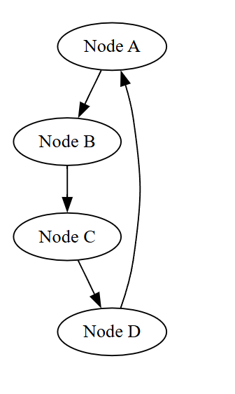─────────────────────────────────────────────────────────────────
2. Distributed Inverted Indexing
Used mainly in search engines.
It maps each keyword to the list of documents or nodes where the keyword appears.
─────────────────────────────────────────────────────────────────
Working Mechanism
- Words are indexed
- Each word points to multiple data locations
- Queries retrieve matching records quickly
─────────────────────────────────────────────────────────────────
Advantages
- Fast text search
- Efficient for document retrieval
─────────────────────────────────────────────────────────────────
3. Range-Based Partitioning
Data is divided based on value ranges.
Example:
- A–F stored on Node 1
- G–L stored on Node 2
- M–Z stored on Node 3
─────────────────────────────────────────────────────────────────
Benefits
- Efficient range queries
- Ordered data storage
─────────────────────────────────────────────────────────────────
Limitation
- Data skew if ranges are uneven
─────────────────────────────────────────────────────────────────
4. Content-Based Indexing
Data is indexed based on content attributes rather than simple keys.
Used in multimedia systems and metadata-driven databases.
─────────────────────────────────────────────────────────────────
Benefits
- Flexible queries
- Rich data retrieval
─────────────────────────────────────────────────────────────────
Challenge
- High indexing complexity
─────────────────────────────────────────────────────────────────
5. Peer-to-Peer (P2P) Indexing
Nodes maintain local indexes and share indexing information with peers.
Lookup requests are forwarded until data is found.
─────────────────────────────────────────────────────────────────
Benefits
- Decentralized
- Fault tolerant
─────────────────────────────────────────────────────────────────
Drawback
- Higher lookup latency
─────────────────────────────────────────────────────────────────
6. Hybrid Indexing Approaches
Hybrid methods combine multiple techniques such as DHT with range partitioning or inverted indexing.
This balances:
- Speed
- Scalability
- Query flexibility
─────────────────────────────────────────────────────────────────
Advantages of Distributed Indexing
- Fast data retrieval
- Reduced network load
- High scalability
- Efficient query processing
─────────────────────────────────────────────────────────────────
Challenges
- Index synchronization
- Fault handling
- Load balancing
- Consistency management
─────────────────────────────────────────────────────────────────
Distributed data indexing and retrieval techniques are essential for enabling fast, scalable, and efficient access to massive datasets stored across distributed systems.
─────────────────────────────────────────────────────────────────
Distributed Hash Tables (DHTs)
Distributed Hash Tables are decentralized data indexing structures used in distributed systems to efficiently store and retrieve key–value pairs across multiple nodes without relying on a central server. Each node is responsible for a specific portion of the data based on a hashing mechanism.
DHTs provide scalable, fault-tolerant, and fast lookup operations, making them ideal for large peer-to-peer and distributed storage systems.
─────────────────────────────────────────────────────────────────
Working Principle of DHTs
- 1. Each data item is assigned a unique key
- 2. A hash function converts the key into an identifier
- 3. The identifier determines which node will store the data
- 4. Lookup requests are routed to the responsible node efficiently
The system organizes nodes in a structured manner to allow fast routing.
─────────────────────────────────────────────────────────────────
Diagram required here — DHT Key-to-Node Mapping
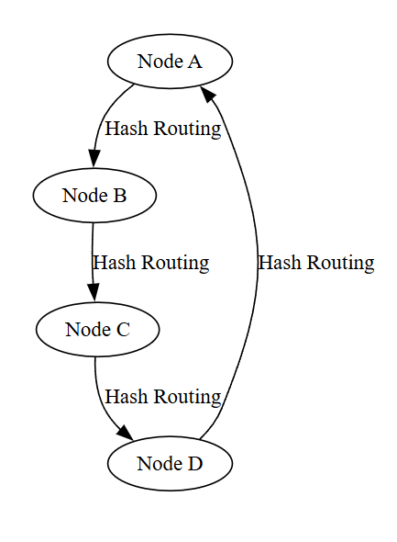─────────────────────────────────────────────────────────────────
Characteristics of DHTs
- Decentralized structure
- High scalability
- Efficient lookup (logarithmic time)
- Fault tolerant through replication
- Automatic load balancing
─────────────────────────────────────────────────────────────────
Advantages
- Fast data retrieval
- No central failure point
- Easily scalable
- Efficient resource utilization
─────────────────────────────────────────────────────────────────
Limitations
- Poor support for complex queries
- High overhead during node joins/leaves
- Limited range query capability
─────────────────────────────────────────────────────────────────
Applications
- Peer-to-peer networks
- Distributed storage systems
- Content distribution
- Decentralized databases
─────────────────────────────────────────────────────────────────
─────────────────────────────────────────────────────────────────
Distributed Inverted Indexing
Distributed inverted indexing is a data retrieval technique primarily used in large-scale search systems where keywords or terms are mapped to the locations of documents or data blocks in a distributed environment.
Instead of searching through all documents, the system directly retrieves relevant data using keyword mappings.
─────────────────────────────────────────────────────────────────
Working Principle
- 1. Each word or term is extracted from documents
- 2. An index is created mapping each term to document identifiers or nodes
- 3. Index entries are distributed across multiple servers
- 4. Queries retrieve relevant documents efficiently
─────────────────────────────────────────────────────────────────
Diagram required here — Distributed Inverted Index Structure
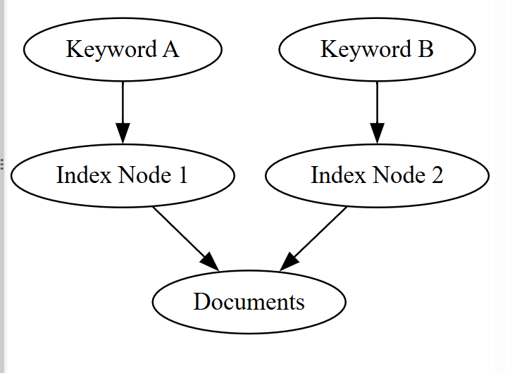─────────────────────────────────────────────────────────────────
Characteristics
- Keyword-based retrieval
- Highly scalable
- Fast query response
- Distributed storage of indexes
─────────────────────────────────────────────────────────────────
Advantages
- Efficient text searching
- Supports large document collections
- Reduced search time
- Parallel query processing
─────────────────────────────────────────────────────────────────
Limitations
- Index maintenance complexity
- High storage overhead
- Synchronization challenges
─────────────────────────────────────────────────────────────────
Applications
- Search engines
- Document retrieval systems
- Web indexing platforms
- Big data analytics
─────────────────────────────────────────────────────────────────
Distributed Hash Tables provide fast decentralized key-based access, while distributed inverted indexing enables efficient large-scale text search — both essential for scalable data retrieval in distributed systems.
─────────────────────────────────────────────────────────────────
Range-Based Partitioning
Range-based partitioning is a data distribution and indexing technique in distributed systems where data is divided among nodes based on predefined value ranges of a key attribute. Each node is responsible for storing and managing data that falls within a specific range.
This method is particularly effective for ordered data and range query operations.
─────────────────────────────────────────────────────────────────
Working Principle
- 1. A partition key is selected (such as customer ID, date, or alphabetical order)
- 2. The total key space is divided into continuous ranges
- 3. Each range is assigned to a specific node
- 4. Data is stored on the node responsible for its range
- 5. Queries are routed directly to the corresponding node
─────────────────────────────────────────────────────────────────
Diagram required here — Range-Based Data Distribution
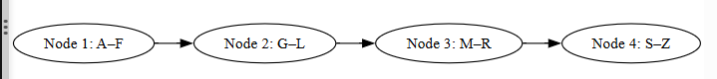─────────────────────────────────────────────────────────────────
Characteristics
- Ordered data storage
- Efficient range queries
- Simple routing mechanism
- Predictable data placement
─────────────────────────────────────────────────────────────────
Advantages
- Fast retrieval for range-based searches
- Good for time-series and sequential data
- Low lookup complexity
─────────────────────────────────────────────────────────────────
Limitations
- Data skew if ranges are uneven
- Hotspot formation for popular ranges
- Requires rebalancing when data grows
─────────────────────────────────────────────────────────────────
Applications
- Financial records
- Log systems
- Time-series databases
- Sorted datasets
─────────────────────────────────────────────────────────────────
Content-Based Indexing
Content-based indexing is a technique where data is indexed based on its actual content or attributes rather than simple keys or ranges. It allows flexible and rich query processing by examining features within the data itself.
This approach is commonly used for multimedia data, documents, and complex datasets.
─────────────────────────────────────────────────────────────────
Working Principle
- 1. Data items are analyzed to extract meaningful features or attributes
- 2. Indexes are built using these content features
- 3. Index entries are distributed across nodes
- 4. Queries search based on content similarity or attributes
─────────────────────────────────────────────────────────────────
Diagram required here — Content-Based Indexing System
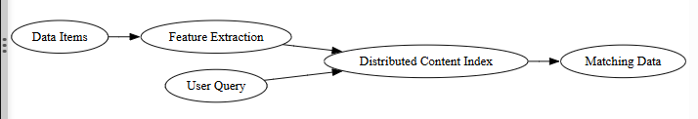─────────────────────────────────────────────────────────────────
Characteristics
- Attribute-driven search
- Supports complex queries
- Suitable for unstructured data
- High retrieval accuracy
─────────────────────────────────────────────────────────────────
Advantages
- Flexible data retrieval
- Powerful search capabilities
- Effective for multimedia and text data
─────────────────────────────────────────────────────────────────
Limitations
- High computational overhead
- Complex index maintenance
- Larger storage requirements
─────────────────────────────────────────────────────────────────
Applications
- Image and video retrieval systems
- Document search engines
- Recommendation systems
- Multimedia databases
─────────────────────────────────────────────────────────────────
Range-based partitioning enables efficient ordered data distribution, while content-based indexing provides powerful search capabilities based on data characteristics — both essential for scalable distributed data retrieval.
─────────────────────────────────────────────────────────────────
Peer-to-Peer (P2P) Indexing
Peer-to-peer indexing is a decentralized data indexing technique in distributed systems where each node (peer) maintains its own local index and collaborates with other peers to locate and retrieve data. There is no central server controlling the indexing process.
Each peer acts both as a data provider and a data requester, enabling scalable and fault-tolerant data retrieval.
─────────────────────────────────────────────────────────────────
Working Principle
- 1. Each peer stores a portion of data and maintains an index for its local data
- 2. When a query is generated, the peer first checks its local index
- 3. If data is not found locally, the query is forwarded to neighboring peers
- 4. The process continues until the required data is located
- 5. The result is returned to the requesting peer
Some systems use structured routing (like DHTs), while others use flooding or random walks.
─────────────────────────────────────────────────────────────────
Diagram required here — P2P Indexing Search Flow
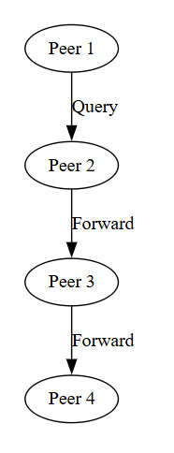─────────────────────────────────────────────────────────────────
Characteristics
- Fully decentralized
- No single point of failure
- Scalable with network growth
- Dynamic node participation
─────────────────────────────────────────────────────────────────
Advantages
- High fault tolerance
- No central bottleneck
- Suitable for large-scale systems
- Flexible data distribution
─────────────────────────────────────────────────────────────────
Limitations
- Higher lookup latency
- Increased network traffic
- Difficult to guarantee consistency
- Complex routing management
─────────────────────────────────────────────────────────────────
Applications
- File sharing systems
- Decentralized storage platforms
- Blockchain networks
- Distributed content sharing
─────────────────────────────────────────────────────────────────
Hybrid Indexing Approaches
Hybrid indexing combines two or more distributed indexing techniques to leverage their strengths while minimizing individual weaknesses. These approaches aim to improve performance, scalability, fault tolerance, and query flexibility.
Common hybrid combinations include:
- DHT + range-based partitioning
- Inverted index + distributed hashing
- Content-based indexing + peer-to-peer routing
─────────────────────────────────────────────────────────────────
Working Principle
- 1. Data is first distributed using one method (such as hashing or partitioning)
- 2. Secondary indexing is applied for faster query processing
- 3. Queries use both structures to locate data efficiently
─────────────────────────────────────────────────────────────────
Diagram required here — Hybrid Indexing System
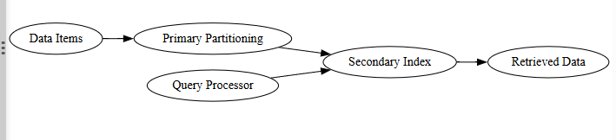─────────────────────────────────────────────────────────────────
Characteristics
- Combines multiple indexing strategies
- Improved query performance
- Enhanced scalability
- Flexible data retrieval
─────────────────────────────────────────────────────────────────
Advantages
- Faster searches
- Better load distribution
- Supports complex queries
- Reduced bottlenecks
─────────────────────────────────────────────────────────────────
Limitations
- Increased system complexity
- Higher maintenance overhead
- More resource consumption
─────────────────────────────────────────────────────────────────
Applications
- Large-scale distributed databases
- Cloud storage systems
- Search engines
- Big data platforms
─────────────────────────────────────────────────────────────────
Peer-to-peer indexing enables decentralized data discovery, while hybrid approaches provide optimized performance by combining multiple indexing techniques for scalable and efficient distributed data retrieval.
─────────────────────────────────────────────────────────────────
Unit II — Distributed Data Management & Storage (Complete Summary)
Unit II focuses on how data is stored, replicated, managed, indexed, and retrieved efficiently in distributed computing environments. It explains the frameworks, technologies, and models used to ensure scalability, fault tolerance, and high performance in large-scale distributed systems.
─────────────────────────────────────────────────────────────────
1. Overview of Distributed Computing Frameworks & Technologies
This section covers the foundational technologies that support distributed systems.
Parallel Computing
Parallel computing divides large computational problems into smaller tasks executed simultaneously across multiple processors or nodes to improve speed and efficiency.
Distributed Computing Models
Models such as client–server, peer-to-peer, cluster-based, and cloud-based architectures define how distributed components interact and share workloads.
Message Passing
Nodes communicate through message passing instead of shared memory. It enables coordination, synchronization, and data transfer in distributed environments.
Distributed File Systems
Distributed file systems such as HDFS and GFS store massive datasets across multiple nodes while presenting a unified file structure. They provide replication, scalability, and fault tolerance.
Cluster Computing & Cloud Platforms
Cluster computing connects multiple machines to act as a single system.
Cloud platforms such as AWS, Azure, and GCP provide distributed infrastructure with scalability, elasticity, and high availability.
Message Brokers & Stream Processing
Message brokers enable asynchronous communication between distributed services.
Stream processing systems handle real-time data streams with low latency.
Edge Computing
Edge computing processes data closer to its source to reduce latency, bandwidth usage, and dependency on centralized data centers.
─────────────────────────────────────────────────────────────────
2. Data Replication & Consistency Models
This section explains how distributed systems maintain multiple copies of data and ensure correctness across replicas.
Replication Techniques
- Eager Replication – Synchronous updates to all replicas
- Lazy Replication – Asynchronous update propagation
- Quorum-Based Replication – Read/write operations require minimum replicas
- Consensus-Based Replication – Nodes agree before committing updates
- Selective Replication – Only important data is replicated
Replication improves availability and fault tolerance but increases communication overhead.
─────────────────────────────────────────────────────────────────
Consistency Models
Consistency models define how updates are observed across replicas.
- Strong Consistency – Immediate synchronization
- Eventual Consistency – Replicas converge over time
- Read-Your-Writes Consistency – User sees own updates
- Consistent Prefix Consistency – Preserves update order
- Causal Consistency – Maintains cause-effect relationships
There is a trade-off between consistency, availability, and performance.
─────────────────────────────────────────────────────────────────
3. Distributed Data Indexing & Retrieval Techniques
Since data is distributed across nodes, efficient indexing is required for fast search and retrieval.
Distributed Hash Tables (DHTs)
Decentralized key-based lookup system using hashing.
Distributed Inverted Indexing
Keyword-based indexing used in search systems.
Range-Based Partitioning
Data divided according to value ranges.
Content-Based Indexing
Indexing based on data attributes and features.
Peer-to-Peer Indexing
Decentralized indexing maintained by peers.
Hybrid Approaches
Combination of multiple indexing strategies for optimized performance.
─────────────────────────────────────────────────────────────────

